**Project Title**

**Project** **Crypter**



**SIES College of Arts, Science &**

**Commerce (Autonomous) Sion (West),**

**Mumbai-400022**

**BACHELOR’S OF SCIENCE IN COMPUTER SCIENCE**.

**SUBMITTED BY**

**Yash Pandey-TCS2324091**

**Abdul Rehman-TCS2324092**

**Sohail Sheikh-TCS2324093.**

**PROJECT GUIDE**

**Soni Yadav**

|  |  |  |
| --- | --- | --- |
| **Sr No.** | **Topics** |  |
|  | **Project Overview** |  |
|  | **Project Planning and Execution** |  |
|  | **Project Outcome** |  |
|  | **Project Evaluation** |  |
| **5.** | **Conclusion** |  |
| **6.** | **Reference** |  |

**Project Overview**

Introduction:

The purpose of this project is to develop and launch an NFT (Non-Fungible Token) marketplace, which is a digital platform where users can buy, sell, and trade unique digital assets represented as NFTs. NFTs are digital tokens that represent ownership of a specific item or piece of content using blockchain technology, providing proof of authenticity and ownership. The main objectives of this project include creating a user-friendly interface, ensuring secure transactions, and fostering a community of artists, collectors, and enthusiasts. The problem this marketplace aims to solve is the lack of a centralized platform for NFT trading, where users can confidently engage in transactions and explore a diverse range of digital assets.

Project Scope:

1. Platform Development: Designing and developing the NFT marketplace platform with essential features like user authentication, digital wallet integration, listing creation, bidding, purchasing, and transaction history.
2. Blockchain Integration: Implementing blockchain technology (such as Ethereum) for creating, storing, and transferring NFTs securely.
3. User Interface (UI/UX): Creating an intuitive and visually appealing interface for users to browse, search, and interact with NFTs easily.
4. Payment Gateway: Integrating a secure payment gateway to facilitate transactions using cryptocurrencies or fiat currencies.
5. Smart Contracts: Developing smart contracts to automate the process of NFT creation, transfer, and royalties’ distribution to creators.
6. Community Features: Implementing social features like user profiles, comments, likes, and follows to encourage user interaction and engagement. Security Measures: Incorporating robust security protocols to protect user data, transactions, and digital assets from unauthorized access and cyber threats.

Stake Holders:

1. Project Team: Developers, designers, blockchain experts, and project managers responsible for the platform's development.
2. Users: Artists, collectors, buyers, and sellers engaging in NFT transactions on the platform. Content Creators: Artists, musicians, game developers, and other creators producing digital assets to be sold as NFTs.
3. Regulatory Authorities: Government bodies and regulatory agencies overseeing digital transactions and ensuring legal compliance.
4. Payment Service Providers: Companies providing payment gateway services for processing cryptocurrency and fiat currency transactions.

Project Setup:(Packages Required)

1. NodeJS

Node.js is an open-source, cross-platform JavaScript runtime environment that executes JavaScript code server-side. It allows developers to use JavaScript for both client-side and server-side scripting, which streamlines the development process. Node.js is commonly used for building scalable network applications and is based on Chrome's V8 JavaScript engine.

1. Yarn

Yarn is a fast, reliable, and secure dependency management tool for JavaScript. It allows developers to manage project dependencies, install packages, and ensure that different machines use the same package versions. Yarn also provides features such as offline mode, parallel package installation, and deterministic dependency resolution, making it a popular choice among JavaScript developers.

1. Truffle

Truffle is a development framework for Ethereum, a popular blockchain platform. It provides a suite of tools for developing smart contracts and decentralized applications (DApps) on the Ethereum blockchain. Truffle simplifies the process of writing, testing, and deploying smart contracts by providing a development environment, testing framework, and asset pipeline for Ethereum-based projects.

1. Ganache

Ganache is a personal blockchain for Ethereum development that you can use to deploy contracts, develop your DApps, and run tests. It provides a local Ethereum blockchain that you can control, allowing you to simulate different network conditions and behaviours. Ganache is often used for development and testing purposes, providing a sandbox environment without the need for real Ether.

1. MetaMask

MetaMask is a popular cryptocurrency wallet and gateway to the Ethereum blockchain. It is a browser extension that allows users to manage their Ethereum-based assets, interact with decentralized applications (DApps), and securely store private keys. MetaMask simplifies the process of accessing Ethereum-based services directly from web browsers, making it user-friendly for both developers and end-users.

Technologies Used:

* + - 1. ReactJS

React.js is a widely used JavaScript library for building user interfaces. Developed by Facebook, it allows developers to create reusable UI components and efficiently update the view when data changes. React's virtual DOM ensures optimal performance, making it popular for building interactive and responsive web applications with seamless user experiences.

* + - 1. TailWindCSS

Tailwind CSS is a utility-first CSS framework that streamlines web development by providing pre-designed classes for styling directly in HTML elements. It embraces a modular approach, allowing developers to create custom designs efficiently. Its simplicity and flexibility make it a popular choice for building modern and responsive user interfaces.

* + - 1. Solidity

Solidity is a high-level, statically typed programming language designed for developing smart contracts on blockchain platforms, particularly Ethereum. It enables developers to create decentralized applications (DApps) by defining the rules and behaviors of smart contracts. Solidity supports object-oriented programming and facilitates secure, transparent, and automated transactions within blockchain networks.

* + - 1. Web3Js

Web3.js is a JavaScript library that allows developers to interact with the Ethereum blockchain. It provides a convenient way to interact with Ethereum nodes using HTTP or IPC connections, enabling the creation of applications that can read data from and send transactions to the Ethereum blockchain. Web3.js is essential for building decentralized applications and integrating Ethereum functionality into web applications.

**Project Planning and Execution**

Project Timeline:

Week 1-2: Conceptualization and Planning

* Ideas for NFT Marketplace: (Day 1-2)
  + - 1. Virtual Art Gallery: Create a platform that replicates the experience of walking through a physical art gallery, showcasing NFT artworks. Users can explore various themed galleries and interact with the art.
      2. Gaming NFT Marketplace: Build a marketplace focused on in-game assets and collectibles. Gamers can buy, sell, and trade unique in-game items, skins, and characters as NFTs, enhancing their gaming experience.
      3. NFT Real Estate: Develop a platform for buying and selling virtual real estate properties as NFTs. Users can build, design, and monetize their virtual properties, creating a unique ecosystem for virtual real estate enthusiasts.
      4. Educational NFT Marketplace: Create a marketplace for educational content, where teachers and content creators can sell educational materials, courses, and tutorials as NFTs. Learners can access exclusive educational content.
* Defining Target Audience and Unique Selling Points: (Day 2-3)
  + Target Audience

Art Enthusiasts and Collectors: Individuals passionate about art looking for unique digital artworks to collect and showcase.

Musicians and Music Lovers: Musicians seeking new ways to monetize their music and fans looking for exclusive and rare music content.

Gamers: Video game players interested in enhancing their gaming experience through unique in-game assets and collectibles.

Investors: Virtual real estate enthusiasts and investors looking for innovative ways to buy, sell, and profit from virtual properties.

Educators and Learners: Teachers, educators, and students searching for a platform to create, share, and access educational content.

* Selling Points

1. Blockchain Security: Utilize blockchain technology to ensure the security, authenticity, and provenance of each NFT, providing a trustworthy marketplace for buyers and sellers.
2. User-Friendly Interface: Develop an intuitive and easy-to-navigate interface for seamless user experience, making it accessible to both beginners and experienced users.
3. Community Engagement: Foster a vibrant community within the platform, allowing users to interact, participate in discussions, and collaborate on projects, creating a sense of belonging.
4. Low Transaction Fees: Implement a competitive fee structure, ensuring that artists, musicians, gamers, real estate developers, educators, and learners receive a fair share of their earnings.
5. Integration with Metaverse: Explore partnerships and integrations with emerging metaverse platforms, enabling users to seamlessly showcase their NFTs within virtual worlds, expanding their reach and visibility.

* Market Research and Feasibility Study: (Day 4-5)

1. OpenSea: Study OpenSea, one of the largest and most popular NFT marketplaces. Analyse their user interface, features, and the types of NFTs being traded. Understand how they attract both buyers and sellers.
2. Rarible: Explore Rarible, a decentralized NFT marketplace that allows users to create, buy, and sell NFTs. Focus on their governance model, which empowers users to shape the platform's future.
3. SuperRare: Investigate SuperRare, a high-end NFT marketplace catering to digital artists and collectors. Examine their curation process, showcasing rare and exclusive digital artworks.
4. Axie Infinity: Research Axie Infinity, a blockchain-based game with an integrated marketplace for trading in-game assets. Understand how they balance gaming experiences with a marketplace ecosystem.

* Identify Trends and User Preferences: (Day 6)

1. NFT Types: Identify popular NFT categories such as art, music, gaming assets, virtual real estate, and more. Determine which categories have a growing demand and why.
2. Interoperability: Study how NFTs are being used across different platforms and metaverse environments. Explore interoperability trends and how NFTs are bridging various virtual worlds.
3. Social and Environmental Impact: Research trends related to the social and environmental impact of NFTs. Understand how the industry is addressing concerns such as energy consumption and carbon footprint.
4. Partnerships and Collaborations: Analyse collaborations between NFT marketplaces, artists, celebrities, and brands. Identify successful partnerships and understand the value they bring to the ecosystem.

* Assess Technical Feasibility and Legal Requirements: (Day 7-9)

1. Blockchain Technology: Assess the feasibility of different blockchain networks like Ethereum, Binance Smart Chain, or others for hosting the NFT marketplace. Consider scalability, transaction speed, and security features.
2. Smart Contracts: Evaluate the technical aspects of implementing smart contracts for NFTs. Understand the programming languages (e.g., Solidity) and security protocols required for creating secure and functional smart contracts.
3. Legal and Regulatory Compliance: Research legal requirements related to NFT trading, intellectual property rights, and consumer protection laws in various jurisdictions. Consult legal experts to ensure the marketplace complies with all necessary regulations.
4. Data Security and Privacy: Develop robust data security measures to protect user information and transaction data. Implement encryption protocols, secure storage solutions, and regular security audits to safeguard user privacy.

* Technical Planning: (Day 10-12)
* Decide a Blockchain Option
  + - * Ethereum: Consider Ethereum for its established NFT ecosystem, but be aware of potential scalability issues and gas fees.
      * Binance Smart Chain (BSC): Explore BSC for its lower transaction fees and faster confirmations, although it might have a smaller user base compared to Ethereum.
      * Polygon (formerly Matic Network): Examine Polygon for its scalability solutions and interoperability with Ethereum. It offers fast and low-cost transactions.
      * Flow by Dapper Labs: Research Flow for its focus on scalability, user experience, and developer-friendly environment, making it suitable for NFTs and gaming applications.
* Define Scope of Work and Assign Tasks: (Day 13-14)

1. Define Project Scope:

* The purpose of this project is to develop and launch an NFT (Non-Fungible Token) marketplace, which is a digital platform where users can buy, sell, and trade unique digital assets represented as NFTs
* The main objectives of this project include creating a user-friendly interface, ensuring secure transactions, and fostering a community of artists, collectors, and enthusiasts.
* The problem this marketplace aims to solve is the lack of a centralized platform for NFT trading, where users can confidently engage in transactions and explore a diverse range of digital assets.

1. Task Assignment:

* Designing: Sohail Sheikh
* Frontend Development: Sohail Sheikh and Abdul Rehman
* Backend Development and Connection to MetaMask: Yash Pandey

1. Regular Communication:

* Weekly Meeting

1. Quality Assurance and Testing

Week 3-4: Development

* Smart Contracts: (Day15-18)
  + Define NFT Smart Contract Requirements
    1. Token Standards: Decide whether to use ERC-721, ERC-1155, or any other token standard based on the requirements of your NFT marketplace. ERC-721 is suitable for unique, indivisible tokens, while ERC-1155 supports both fungible and non-fungible tokens.
    2. Metadata Standard: Plan the metadata structure for your NFTs. Consider using IPFS (Interplanetary File System) to store metadata off-chain while linking it to the tokens on-chain. This approach reduces gas fees and ensures decentralized access to metadata.
  + Smart Contract Development
    - * Develop Smart Contracts:
        1. Write and deploy the smart contracts for creating, transferring, and managing NFTs. Include functions for minting new tokens, transferring ownership, and querying token metadata.
        2. Implement access control mechanisms to ensure that only authorized users can perform specific actions, such as minting new NFTs or transferring ownership.
      * Integrate with Metadata:
* Implement functionality to link the NFTs with their corresponding metadata stored on IPFS. Generate unique URIs for each NFT, allowing users to access detailed information about the tokens.
* Security Auditing and Testing: (Day 19-20)

1. Security Audit

* + Conduct a thorough security audit of the smart contracts. Consider employing third-party security firms or experts to identify vulnerabilities and potential exploits.
  + Address security issues discovered during the audit to enhance the robustness of the smart contracts.
    1. Testing
* Create a comprehensive suite of unit tests to validate the functionality of the smart contracts.
* Perform integration testing to ensure seamless interaction between different components of the system.
* Conduct simulation testing on a testnet to observe contract behavior in a controlled environment.
* Deployment and Optimization: (Day 21-22)
  + 1. Deployment
* Deploy the audited and tested smart contracts on the chosen blockchain network (Ethereum, Binance Smart Chain, etc.).
* Verify the contracts on the blockchain explorer to enhance transparency and trust among users.
  + 1. Gas Fee Optimization
* Optimize the smart contracts to minimize gas fees. Consider techniques such as batch processing and efficient storage to reduce transaction costs for users.
* Monitor gas usage and make adjustments to the contract code if necessary to optimize costs further.
  + 1. Documentation
* Document the deployed smart contracts, including their functionality, methods, and events. Provide clear and comprehensive documentation for developers who might interact with the contracts in the future.
* Frontend and Backend Development: (Day 23-32)
  1. Design User Interface and User Experience (UI/UX)
     + - User Flow

ER Diagram:

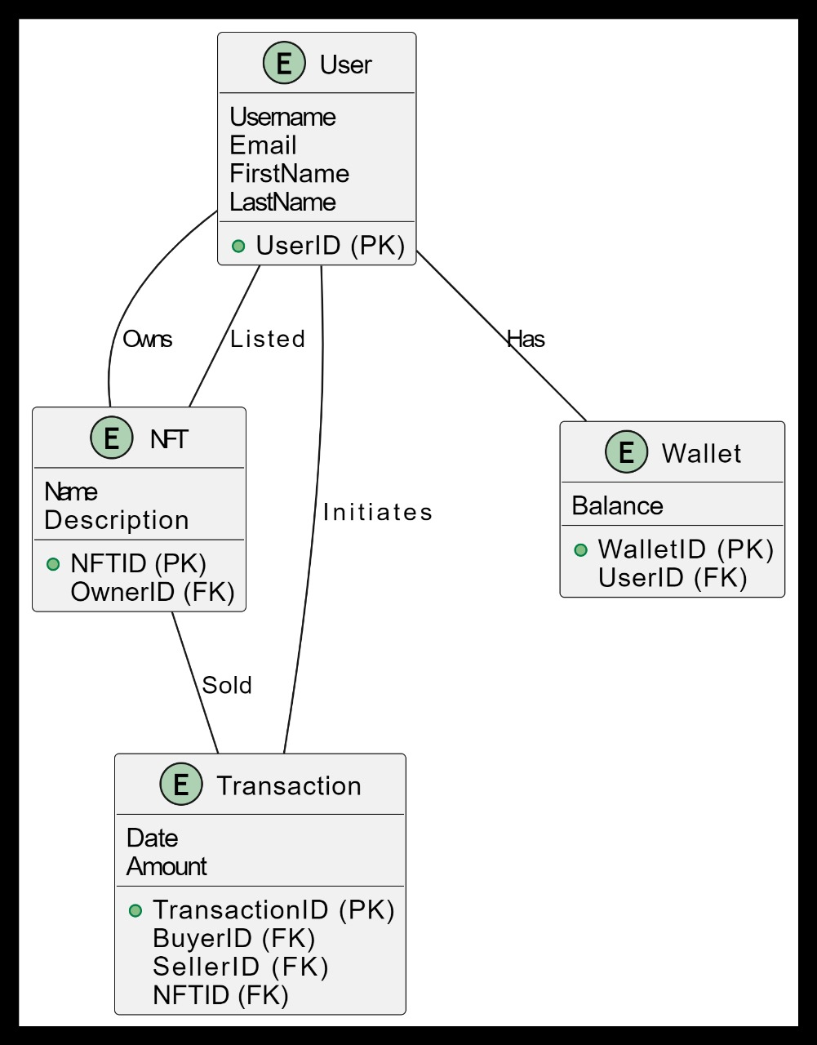

Collaboration Diagram:

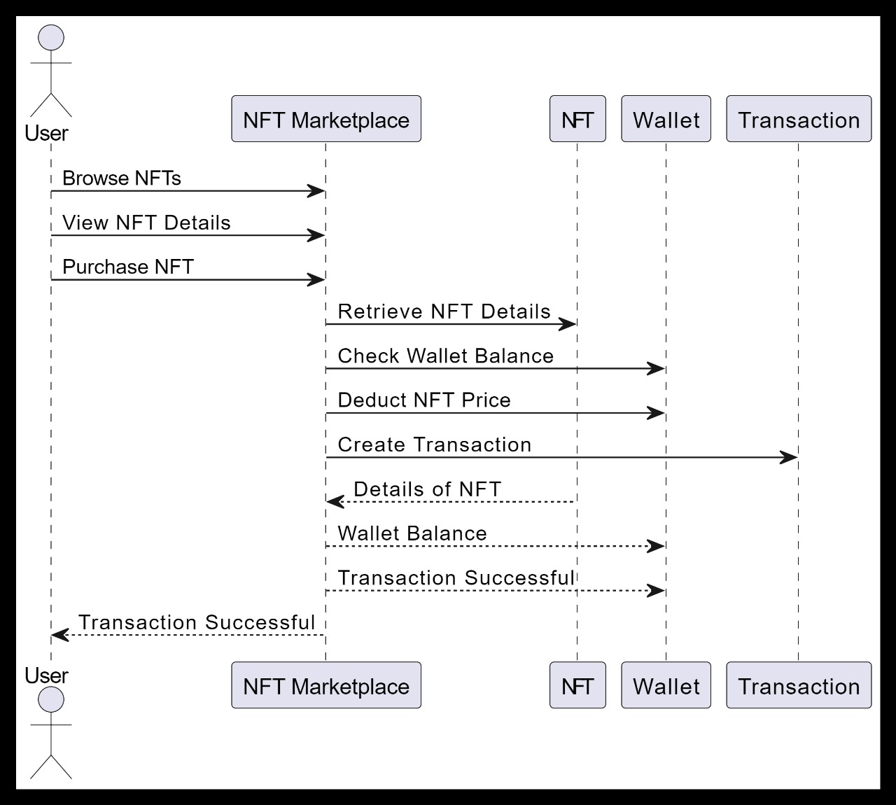

Activity Diagram:

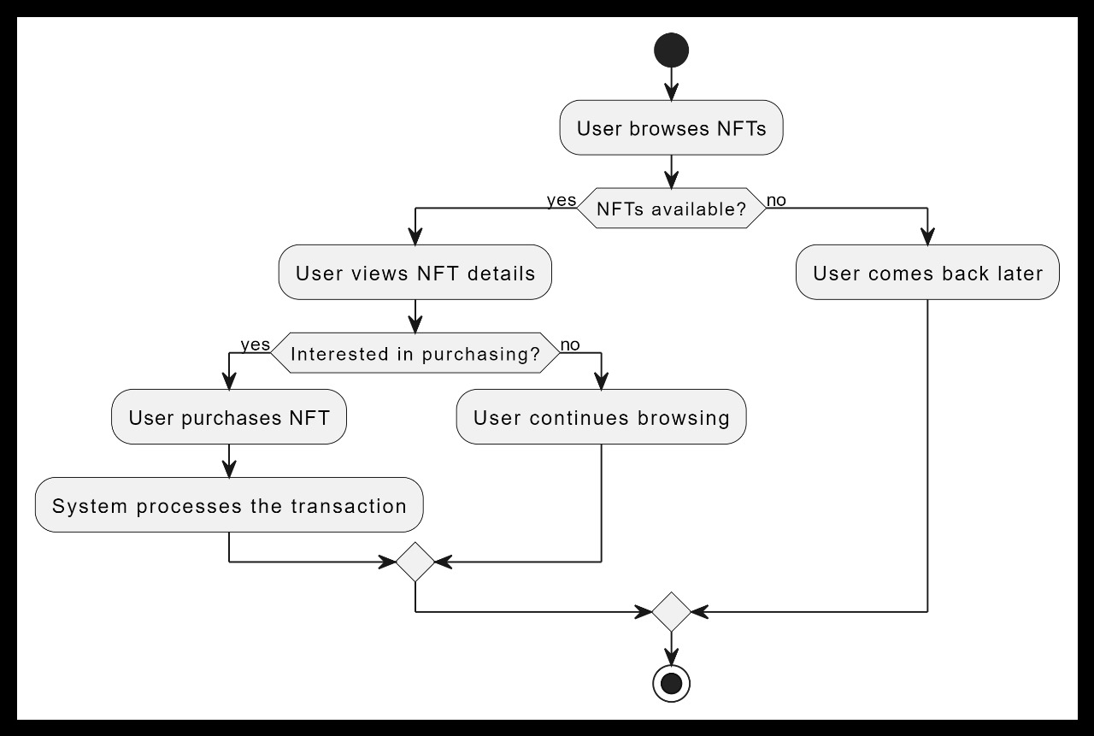

Use Case:

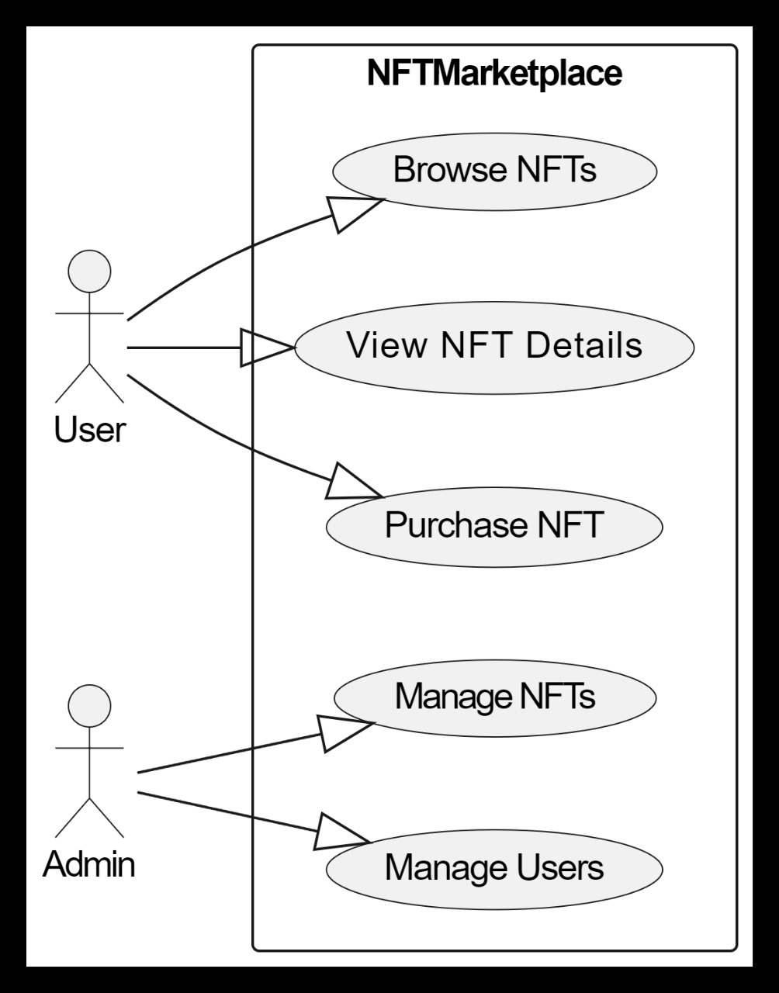

Sequence Diagram:

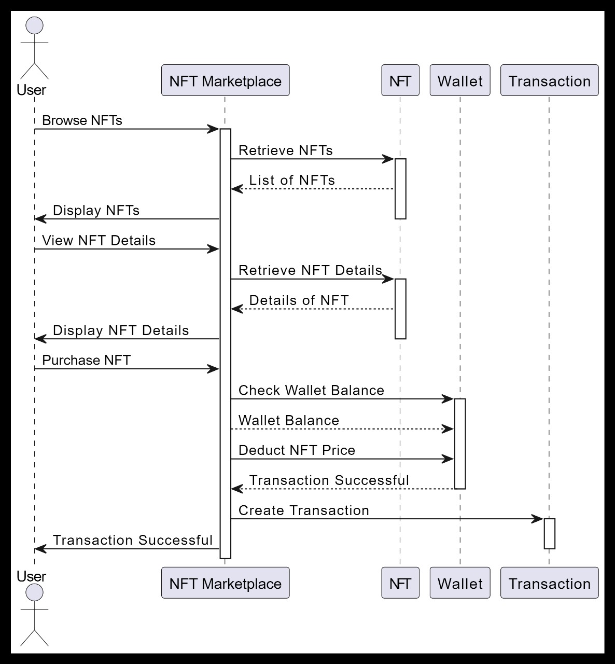

* + - * Visual Design

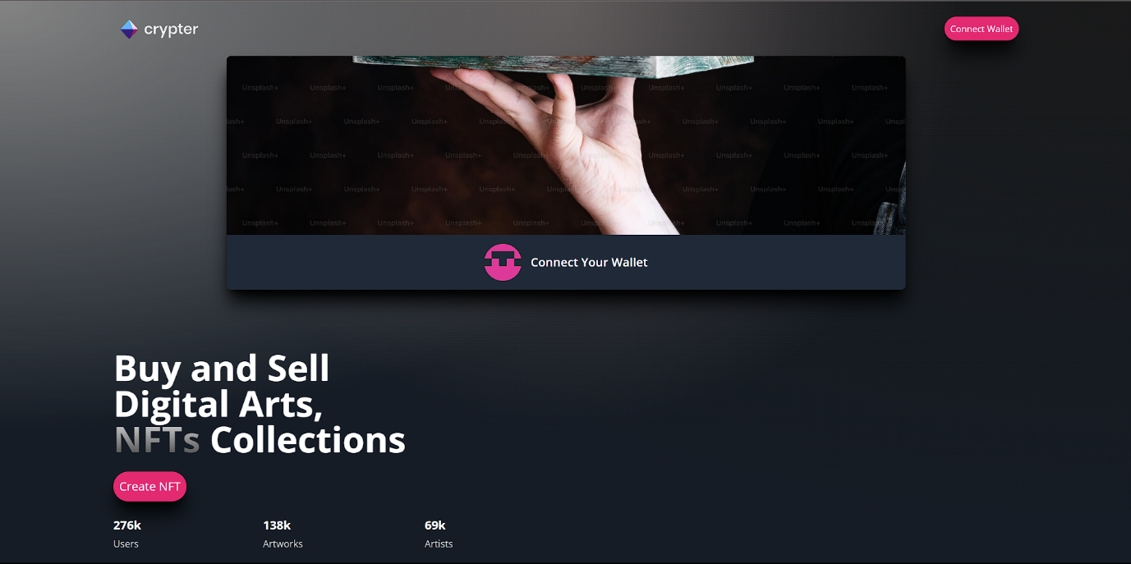

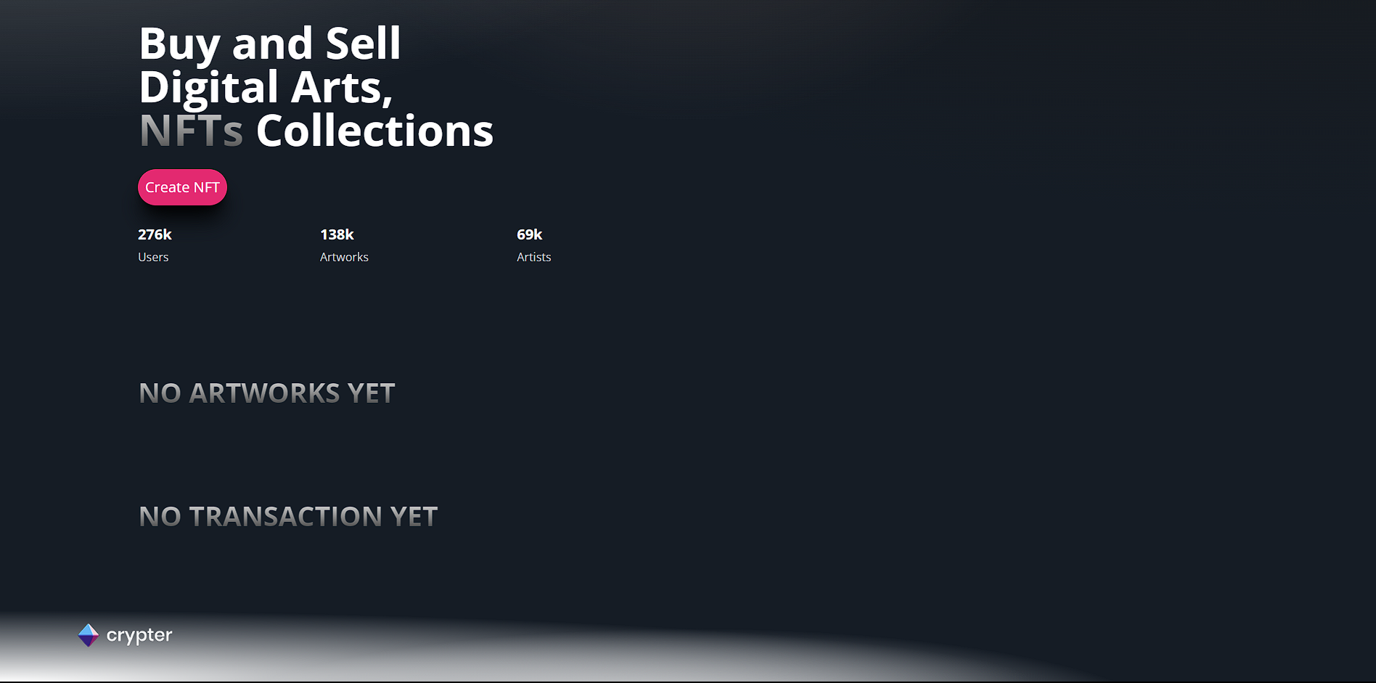

* 1. Frontend Development
     + - 1. Selected Frontend Technologies: Using ReactJS and TailWindCSS
         2. Develop User Interface
         3. Integrate with Smart Contracts: Integrate the frontend with the NFT smart contracts to enable functionalities like viewing owned NFTs, initiating transactions, and interacting with the blockchain.
  2. Backend Development
     + - 1. Develop User Authentication
* Implement secure user authentication and authorization mechanisms. Consider using JWT (JSON Web Tokens) for token-based authentication.
  + - * 1. NFT Minting and Transaction Processing
* Develop backend logic for NFT minting, allowing users to create and list new NFTs for sale.
* Implement transaction processing logic, ensuring secure and efficient handling of payments and transfers.
  + - * 1. Security Measures
        2. Testing and Debugging
* Perform extensive testing on both frontend and backend components. Conduct unit tests, integration tests, and end-to-end tests to ensure the entire system functions seamlessly.
  + - * 1. Deployment and Monitoring
* Deploy the backend infrastructure on a reliable server or cloud platform.
* Set up monitoring tools to track system performance, errors, and user activities, enabling proactive issue resolution.

Week 5-6: Testing and Refinement

* Alpha Testing: (Day 33-40)
  1. Internal Testing
     + - Conduct alpha testing internally.
       - Test all features, including NFT minting, transactions, user authentication, and smart contract interactions.
       - Identify and document bugs, glitches, and usability issues.
  2. Smart Contract Security Testing
     + - Perform security audits and penetration testing specifically focused on the smart contracts.
       - Identify potential vulnerabilities such as re-entrancy attacks, overflow/underflow issues, or insecure access control.
       - Address and fix any security concerns discovered during testing.
  3. Bug Fixing
     + - Prioritize and fix identified bugs promptly
       - Test the fixes thoroughly to ensure they do not introduce new issues
* Beta Testing and Feedback: (Day 41-47)
* Limited Beta Launch
* Feedback Gathering
* Gather feedback on user interface, functionality, transaction process, NFT minting, and overall user experience.
* Data Analysis
  + Analyse the collected data and feedback systematically.
  + Identify common themes or recurring issues mentioned by beta testers.
* Iterative Refinement
* Continuous Testing
  + Continuously testing the platform during the beta phase to identify and fix any new issues that might arise as more users interact with the system

Week 7-8: Deployment and Post Launch Activities

* Deployment
  + 1. Final Testing
  + Conduct comprehensive testing of the entire platform, including frontend, backend, smart contracts, and all integrated components.
  + Simulate real-world scenarios to ensure the platform can handle the expected user load and transactions.

2. Documentation and Support

* Prepare comprehensive documentation for users, including guides on how to mint NFTs, buy/sell, and troubleshoot common issues.
* Set up a customer support system to assist users with inquiries and problems.

3. Analytics and Monitoring

* Regularly collect and analyse user feedback. Use this information to implement further improvements and new features.
* Stay updated with the latest trends and technologies in the NFT space to adapt your platform accordingly.

4. Continuous Improvement

* Regularly collect and analyse user feedback. Use this information to implement further improvements and new features.
* Stay updated with the latest trends and technologies in the NFT space to adapt your platform accordingly

5. Bug Fixing and Maintenance

* Implement a system for users to report bugs or issues. Address reported problems promptly to maintain a positive user experience.
* Schedule regular maintenance periods to apply updates, security patches, and improvements without disrupting the platform's operation.

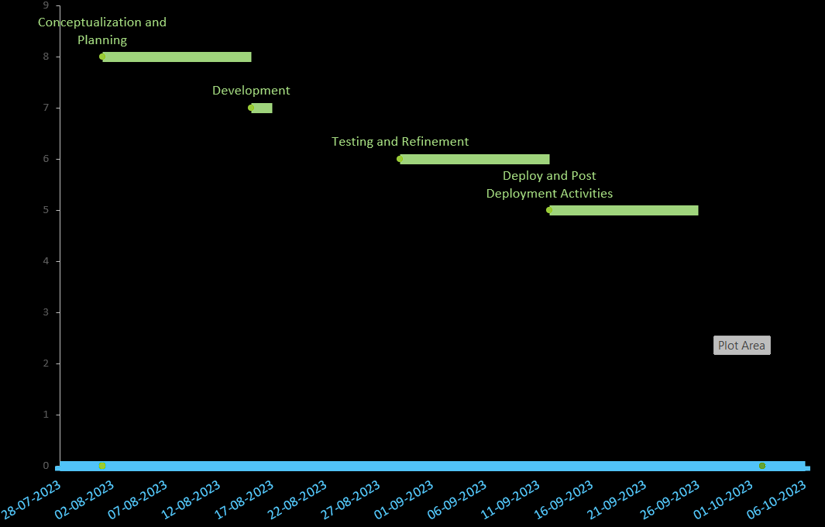

Code Snippets:

File Structure

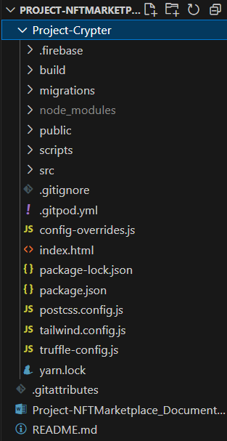

Migration:

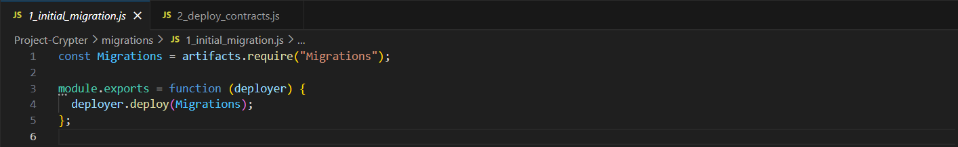

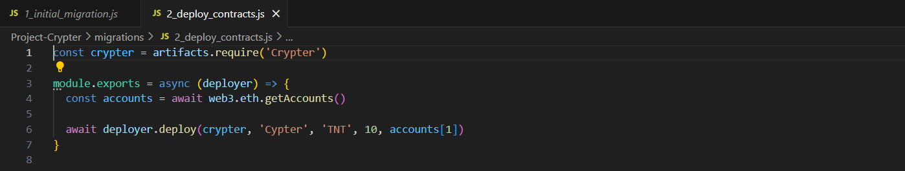

Public:

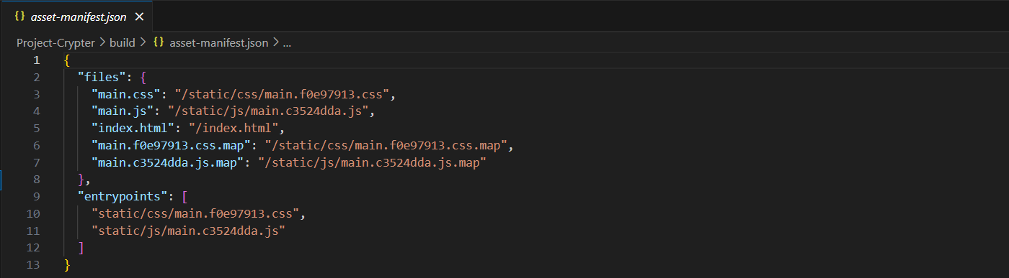

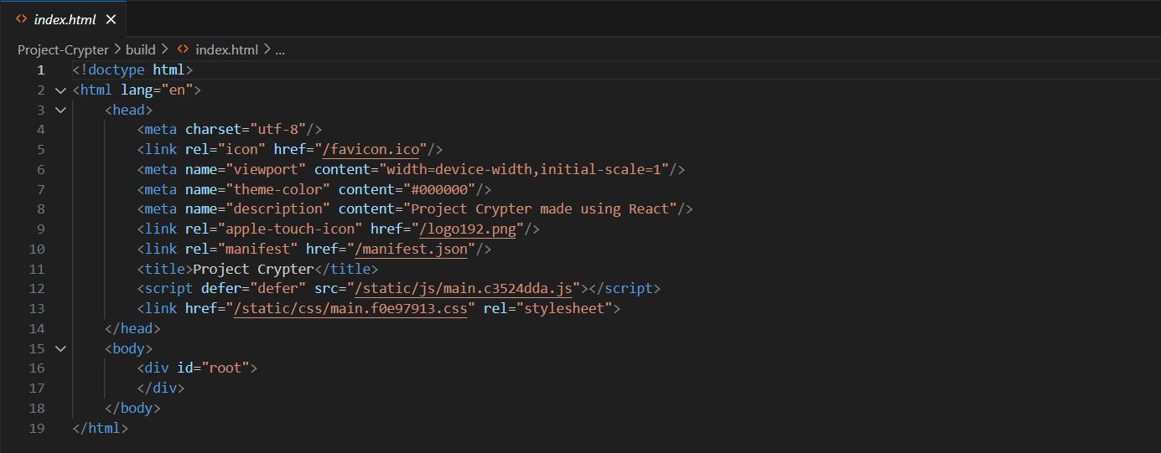

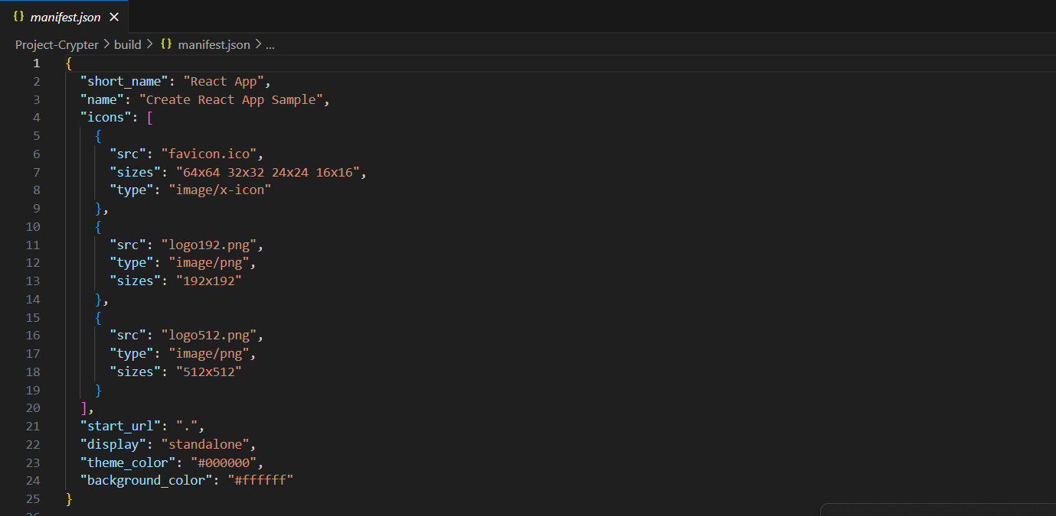

Scripts:

BuyNFT.js

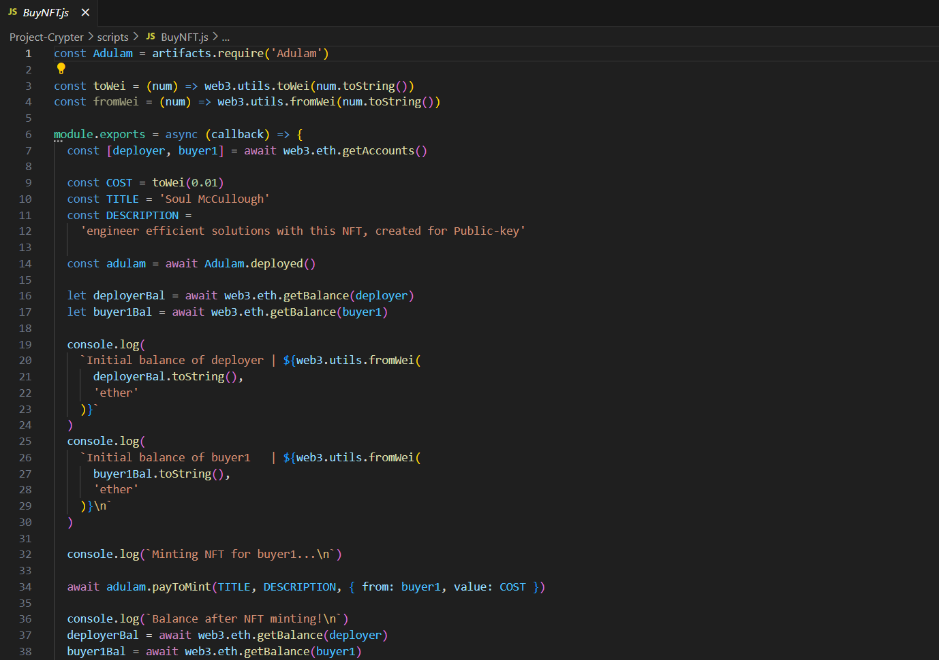

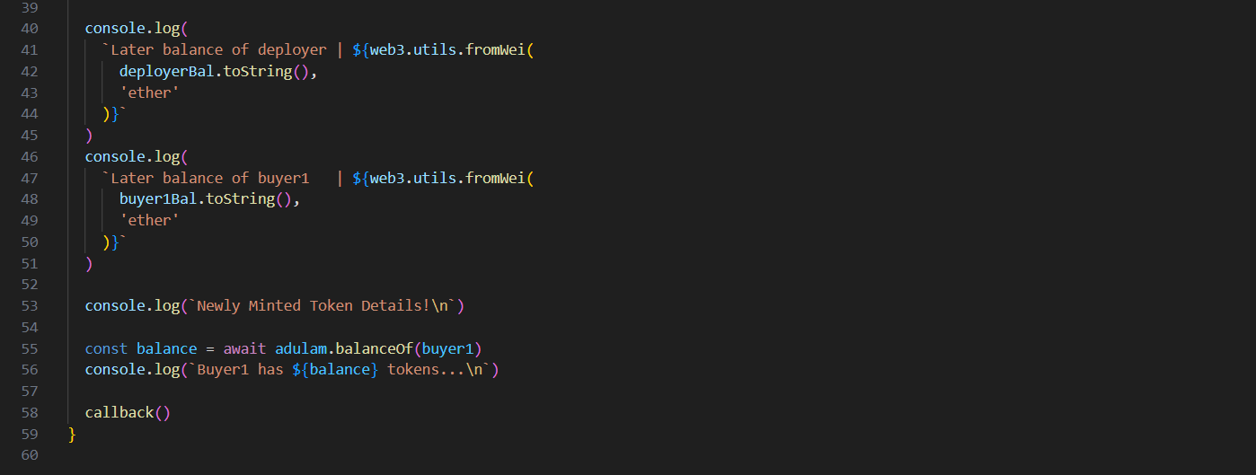

deploy.js

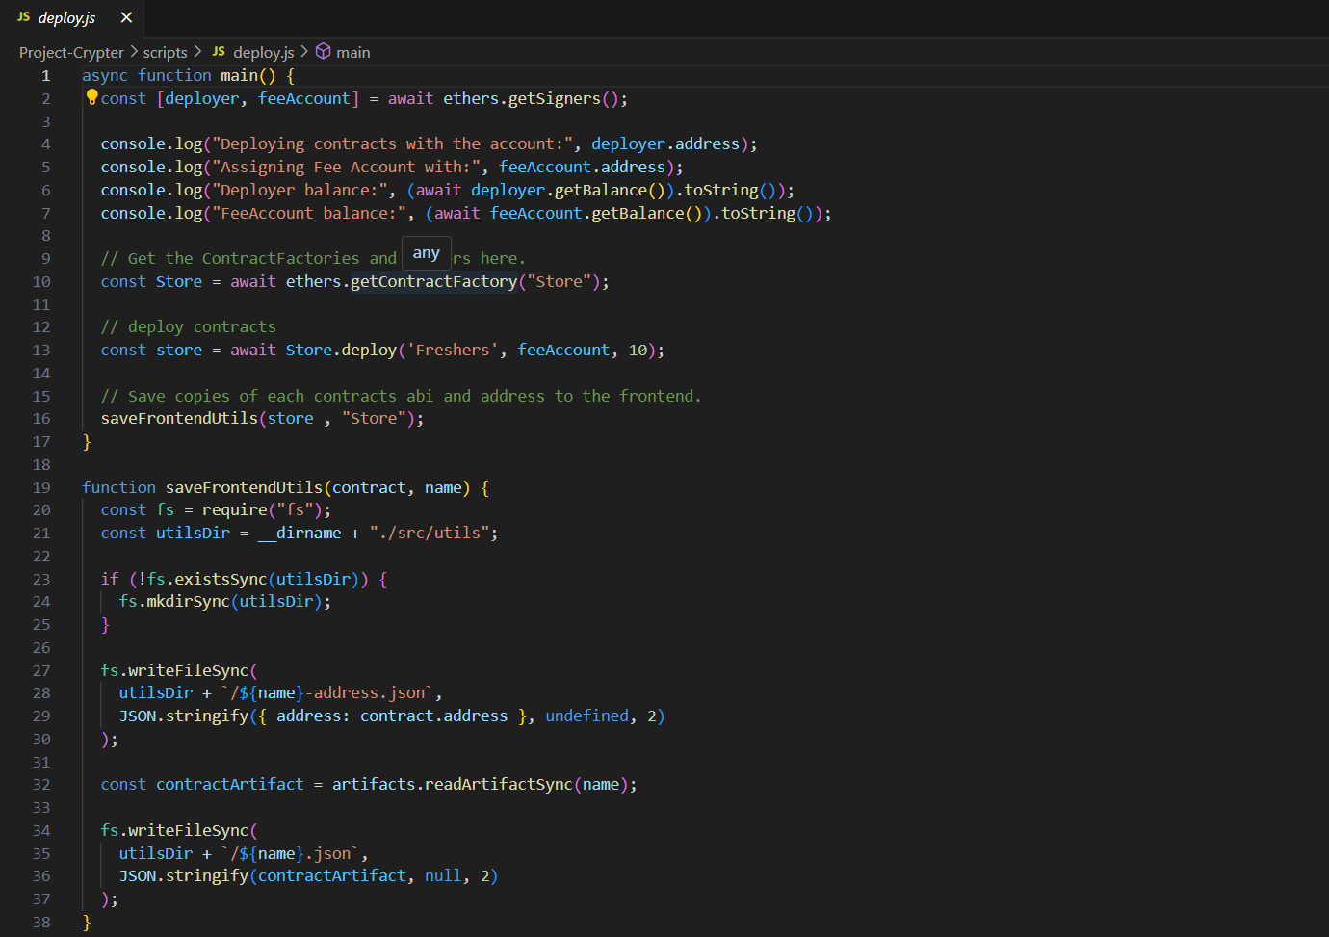

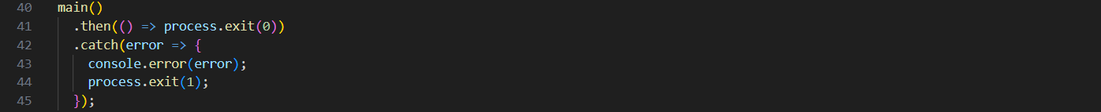

Src: 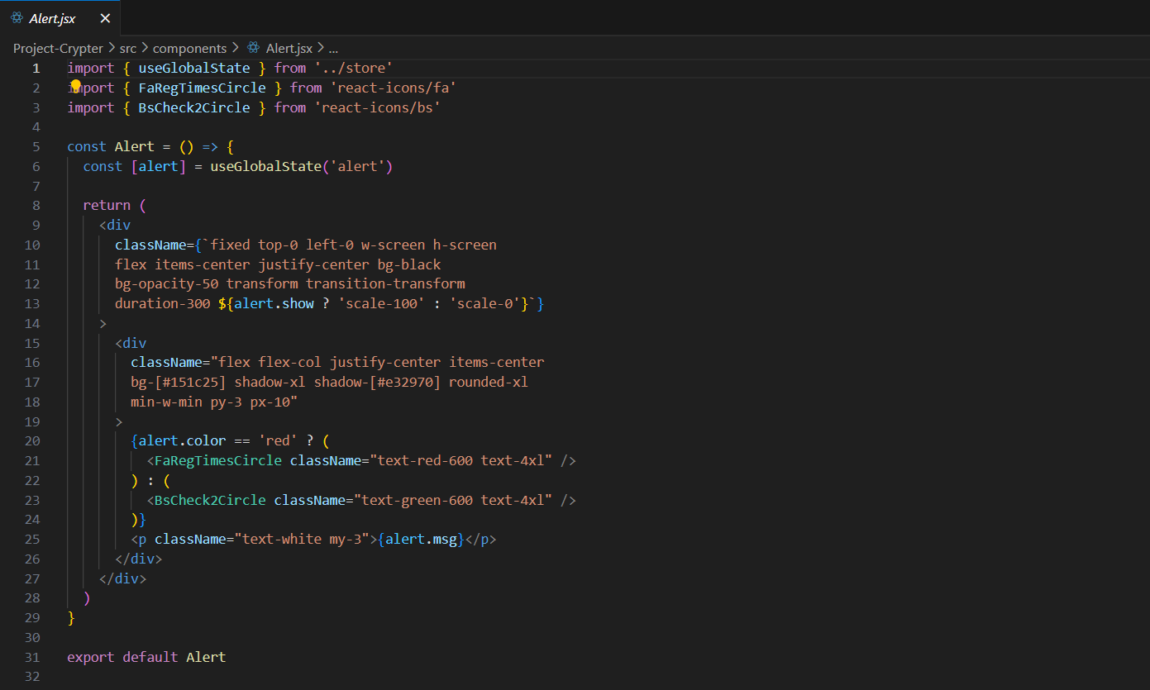

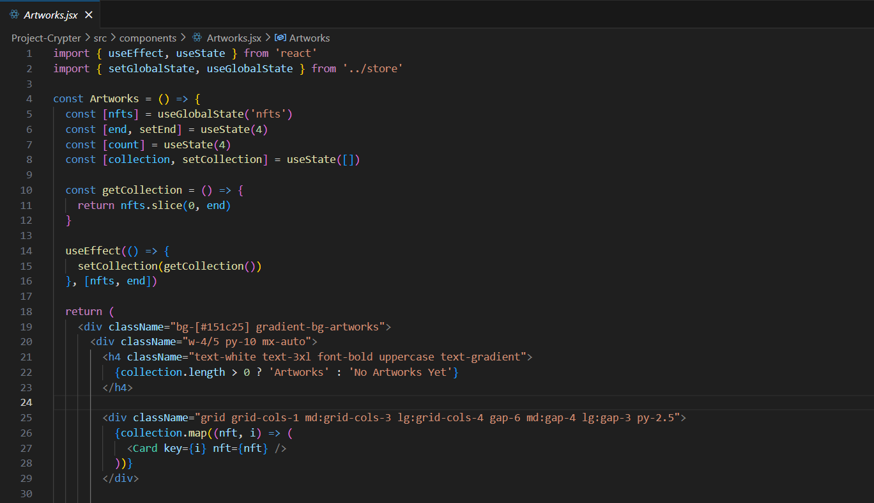

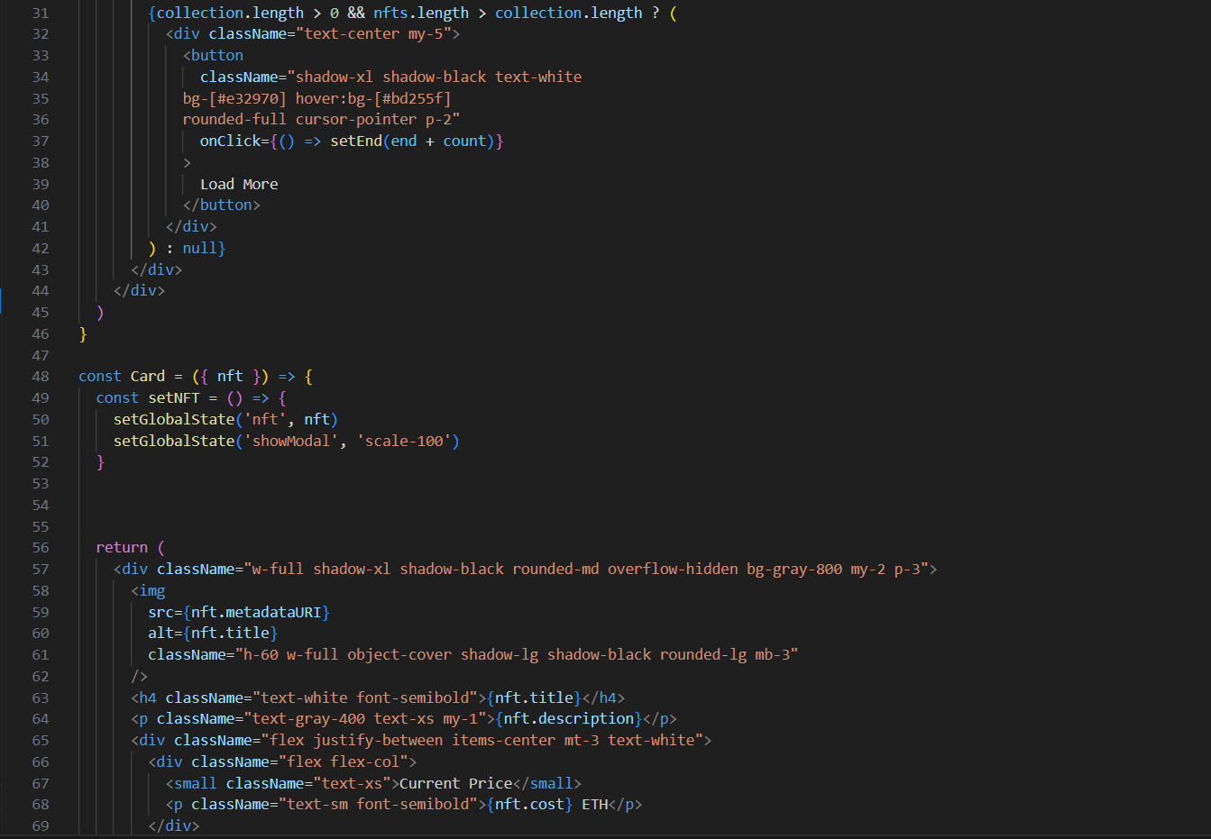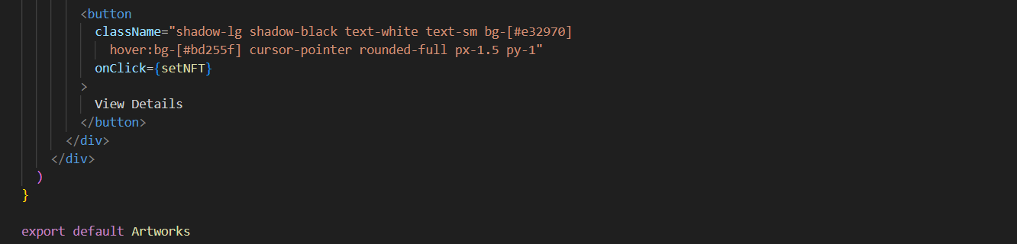

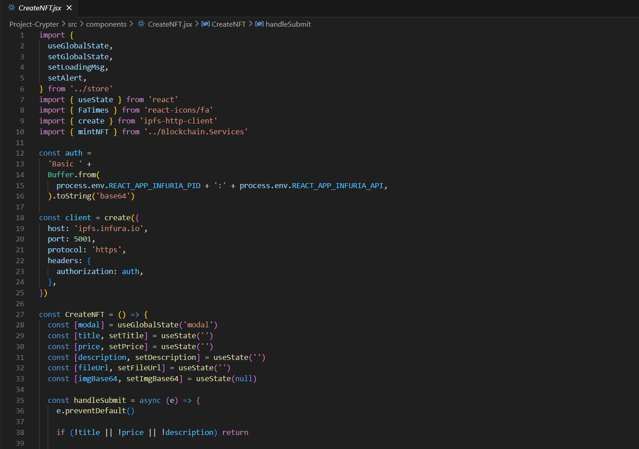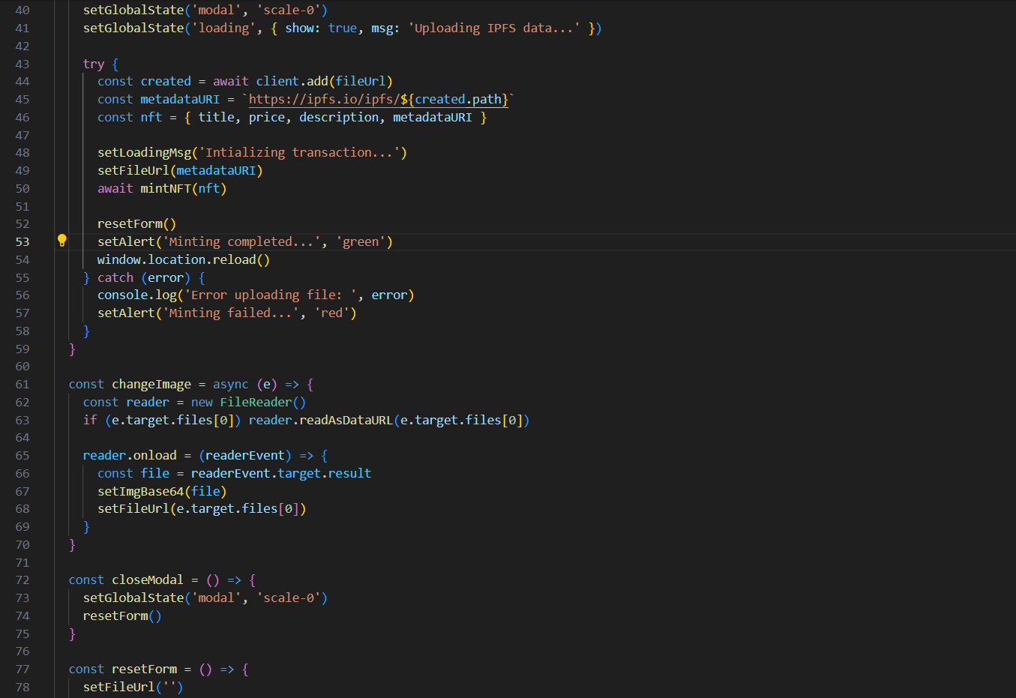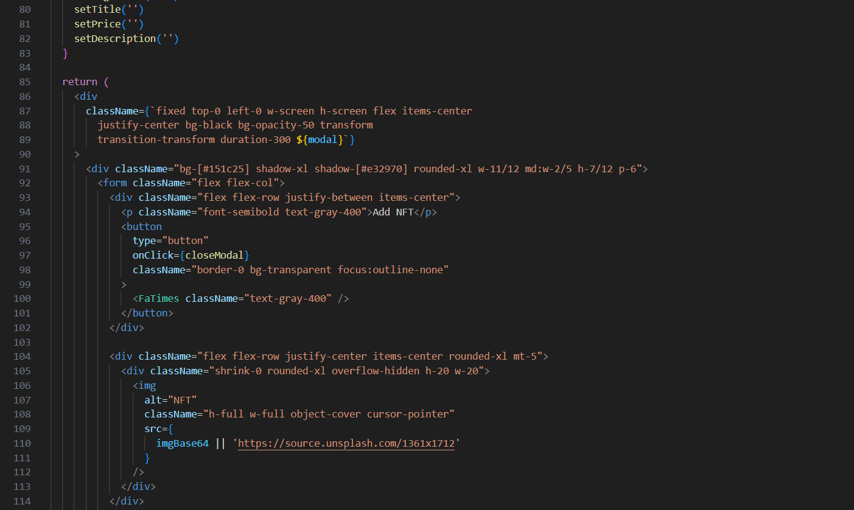

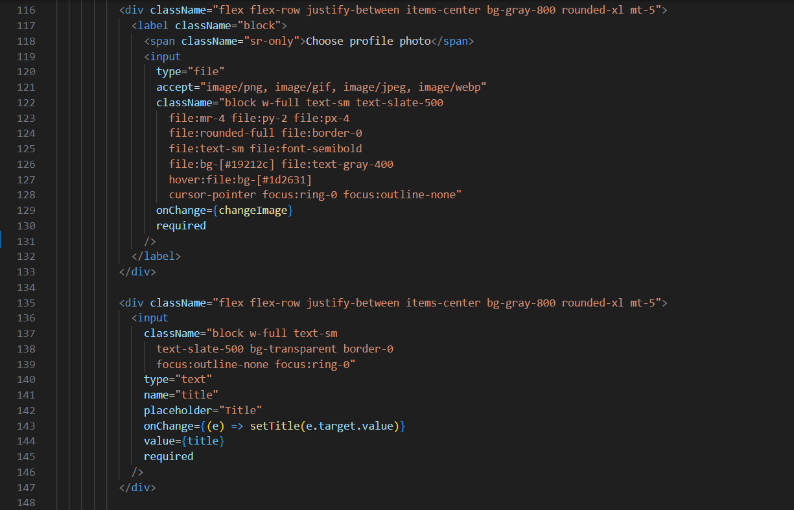

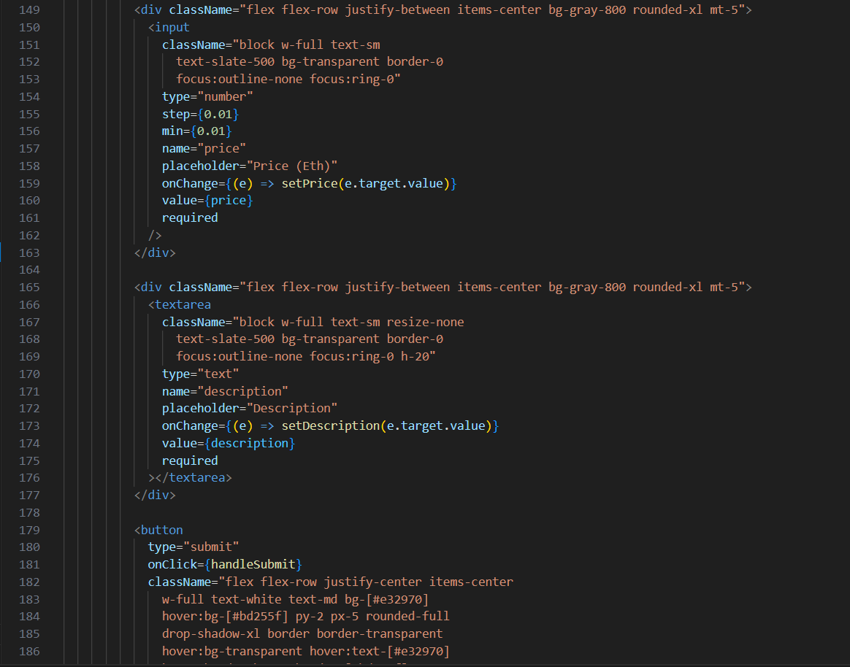

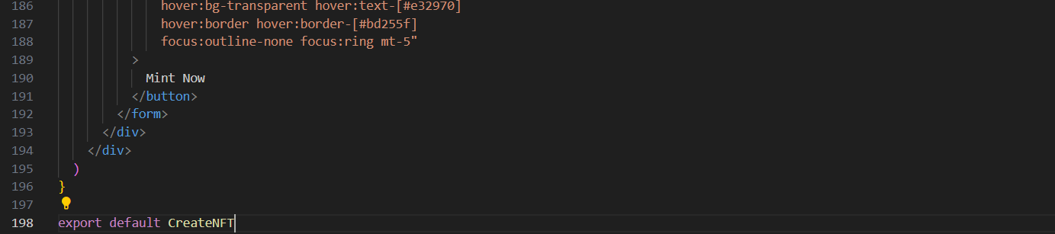

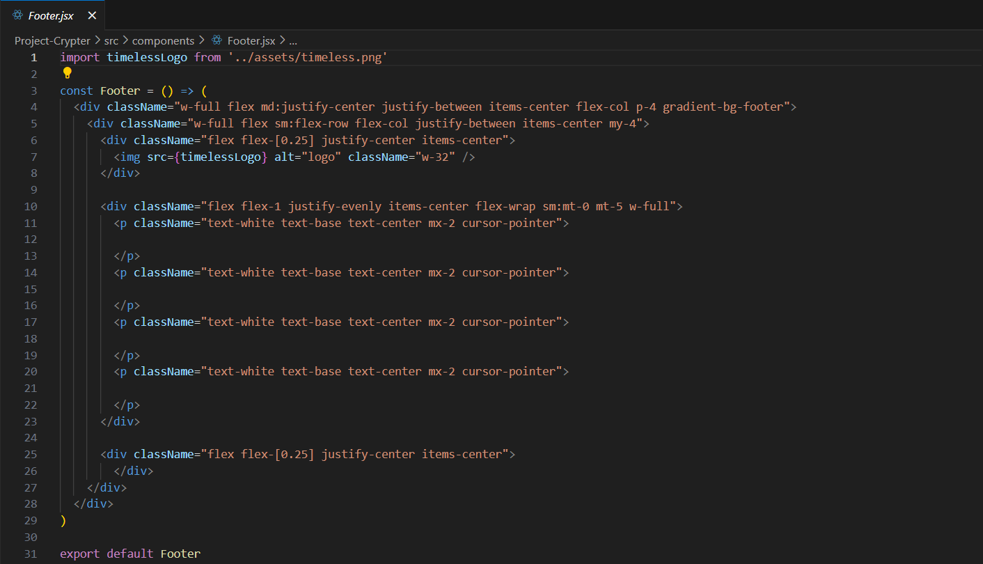

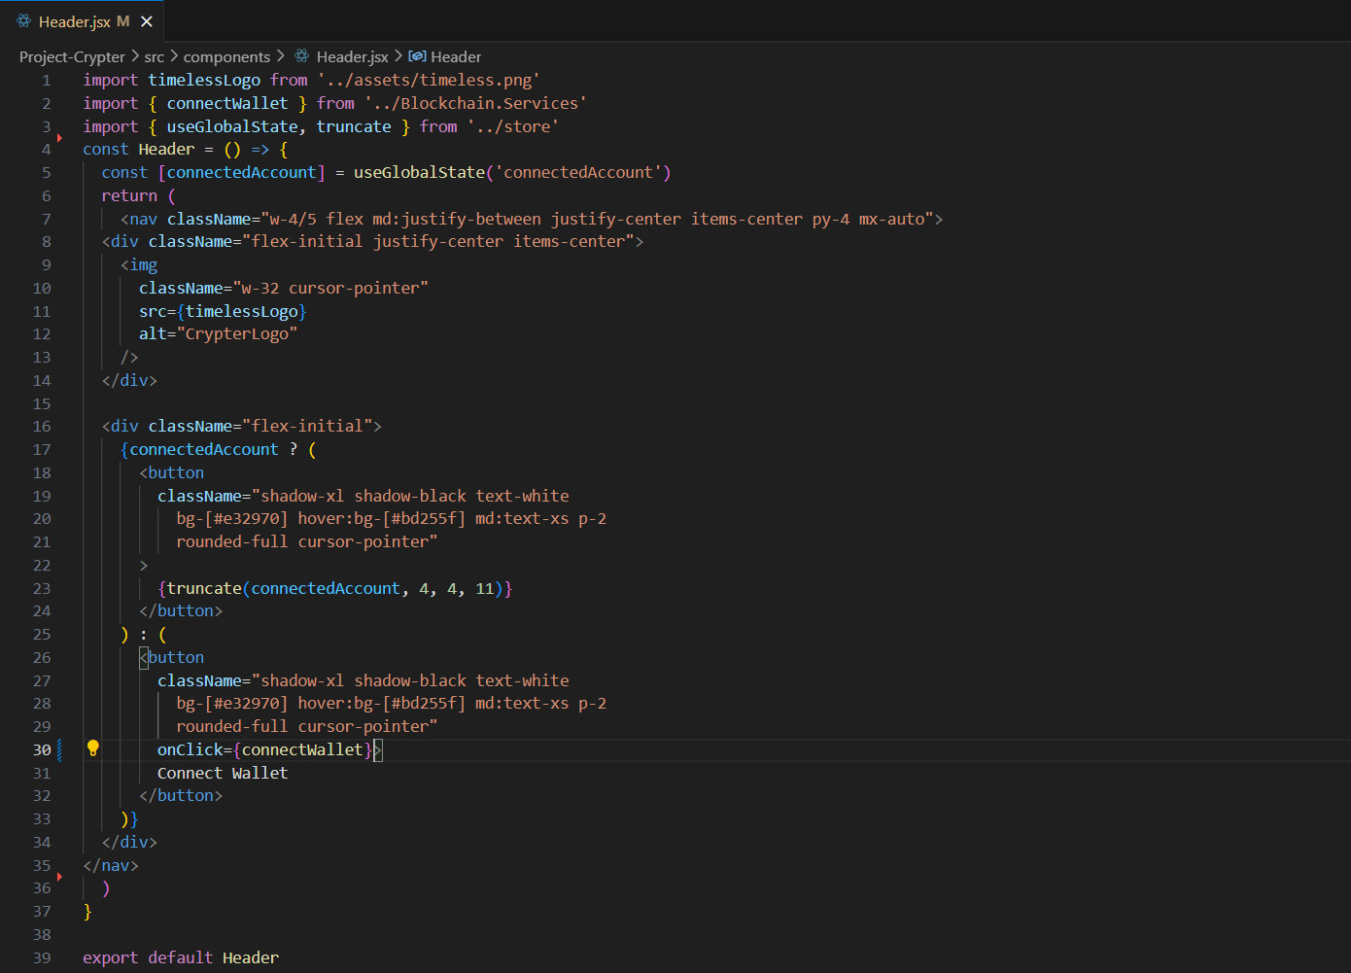

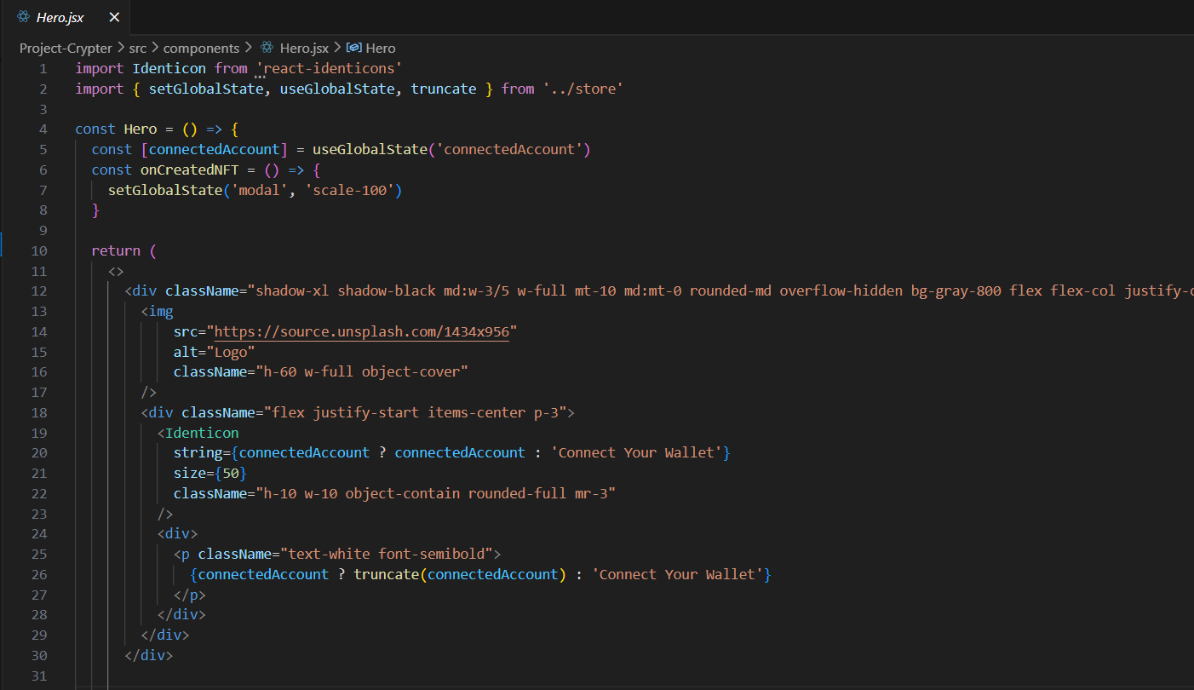

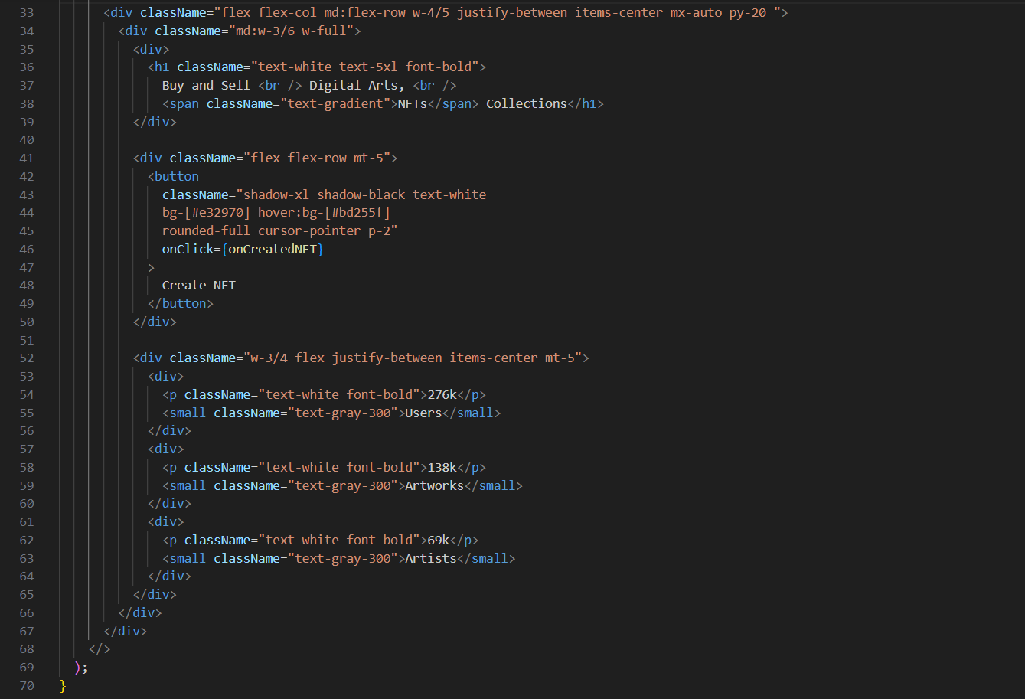

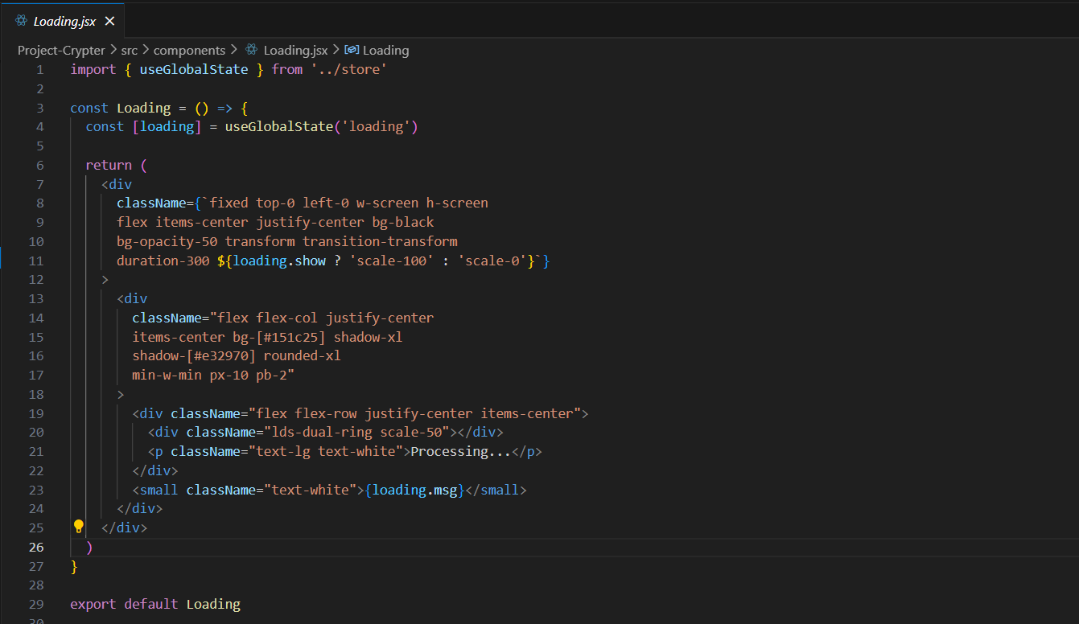

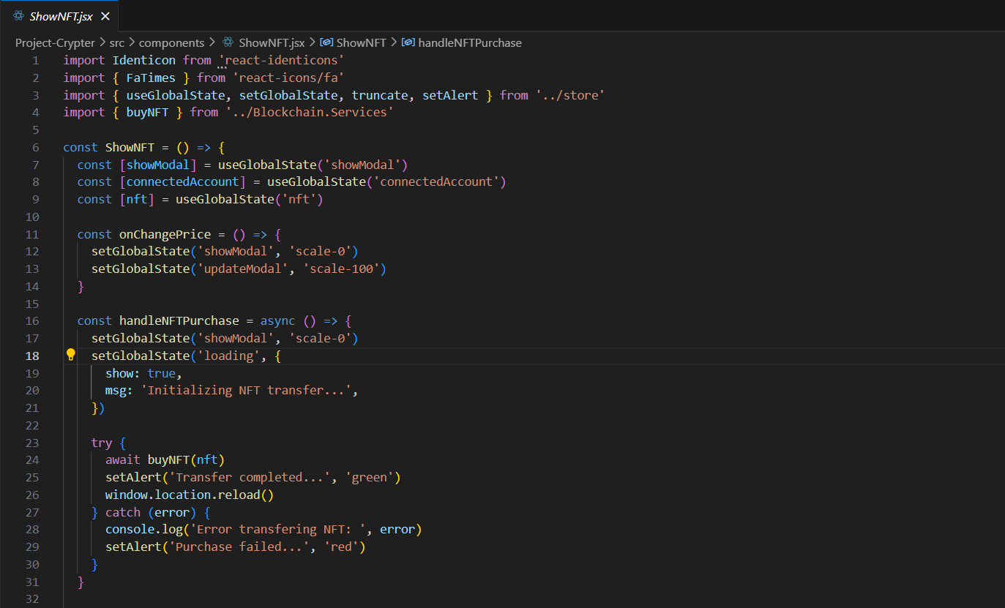

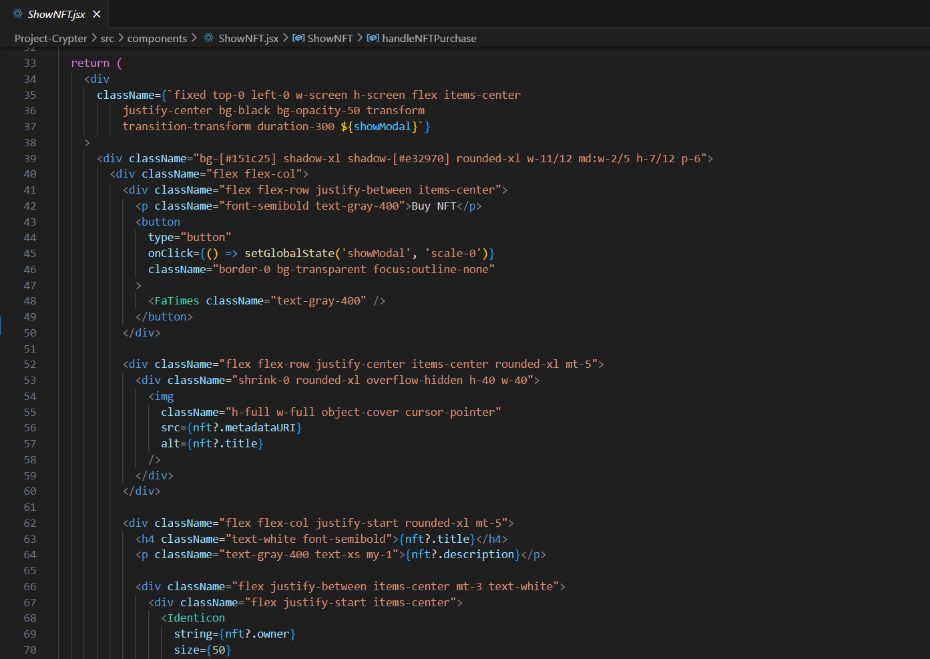

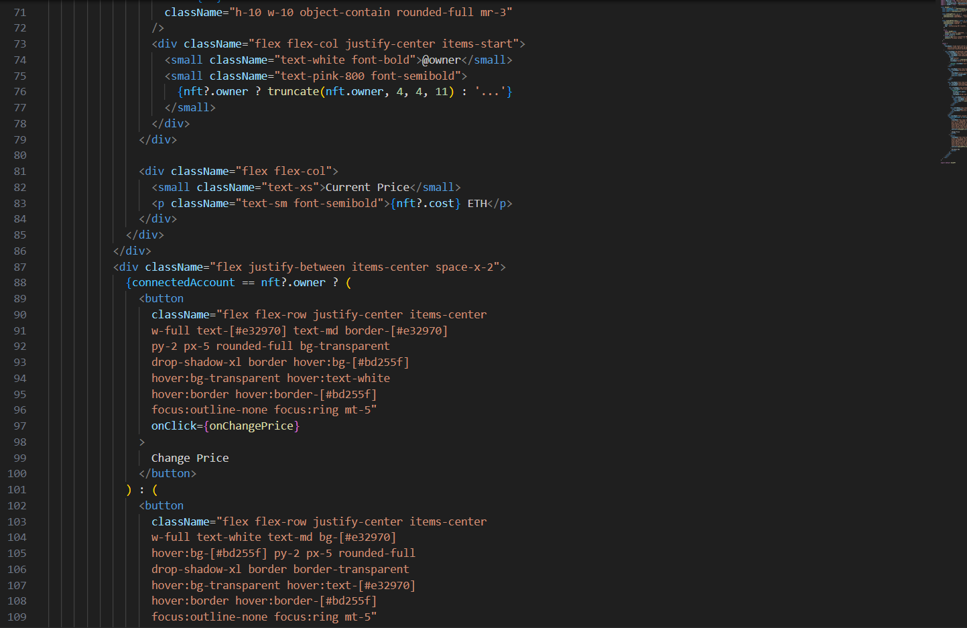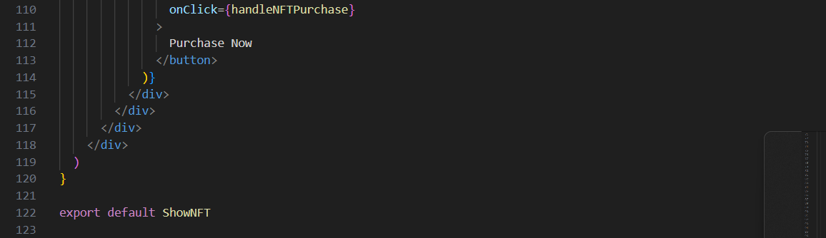

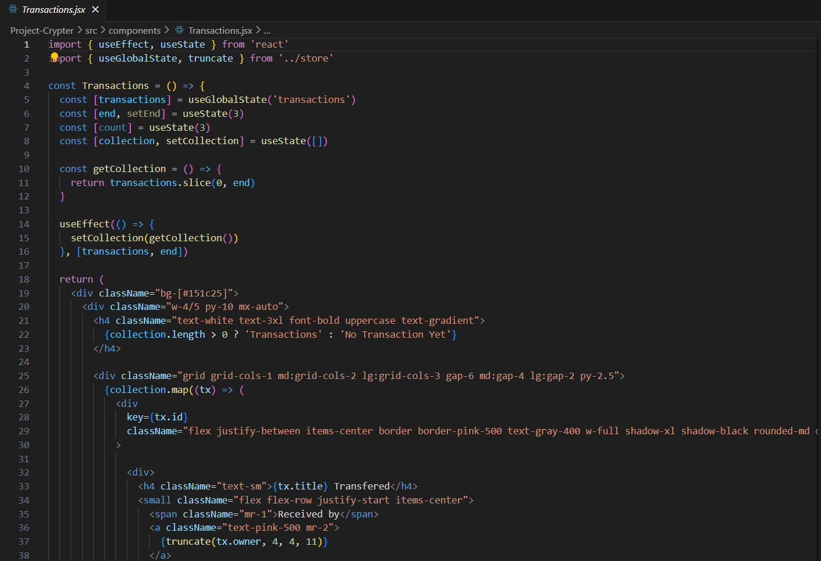

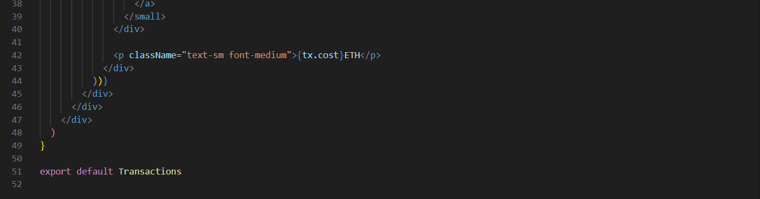

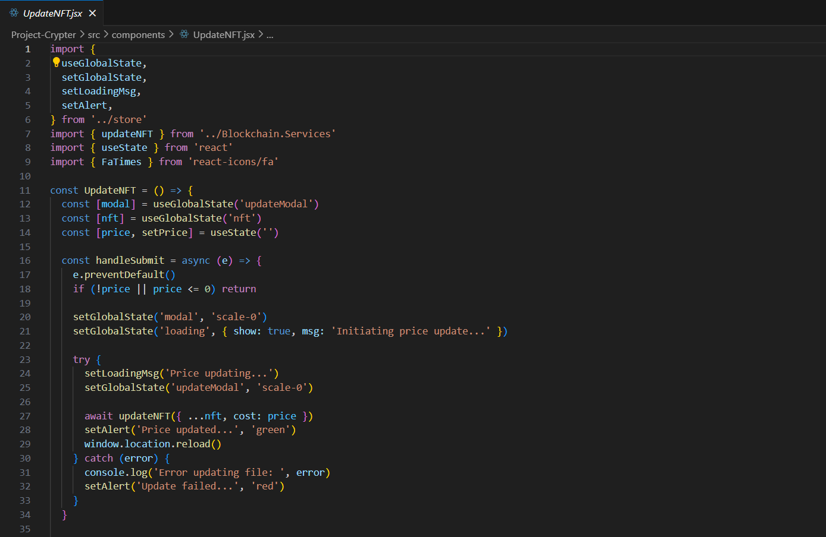

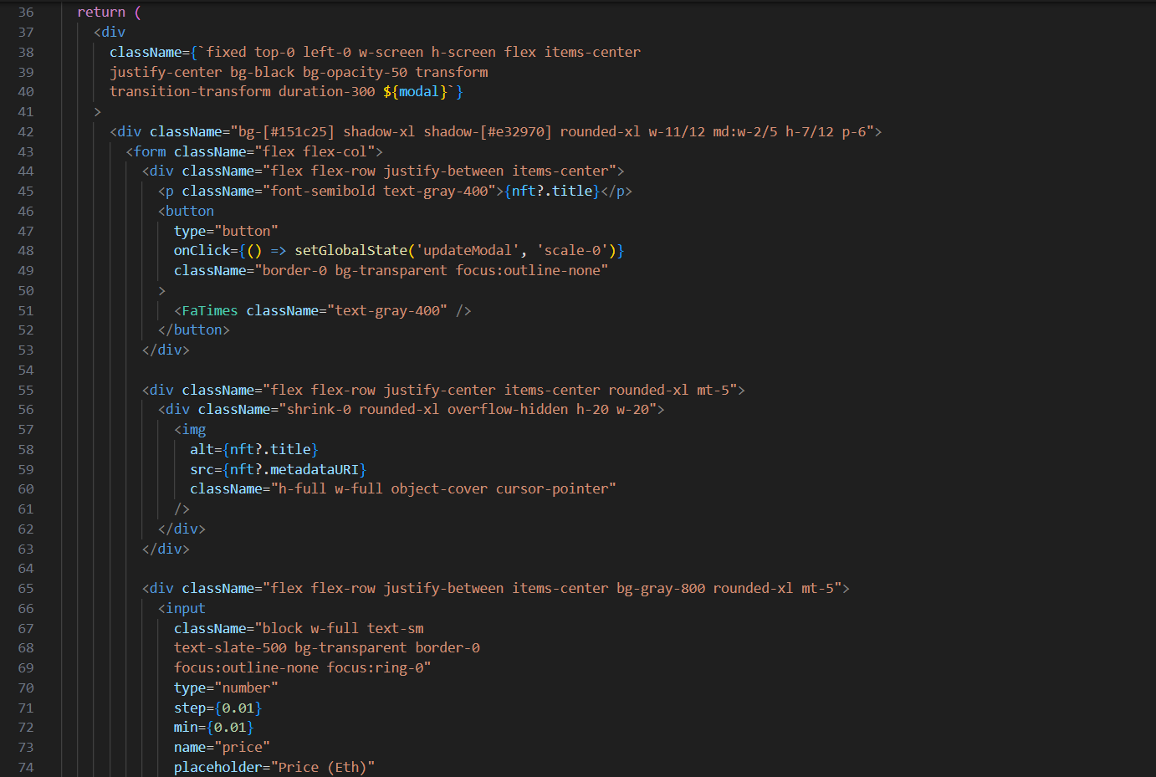

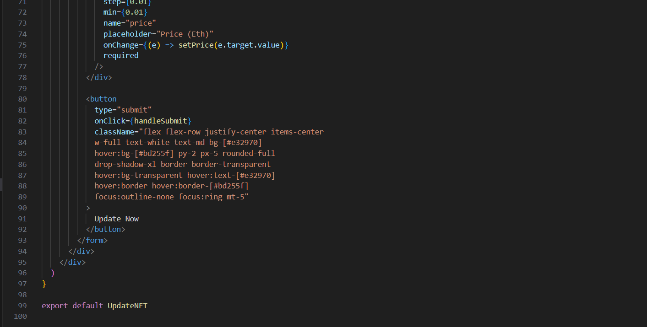

Contracts:

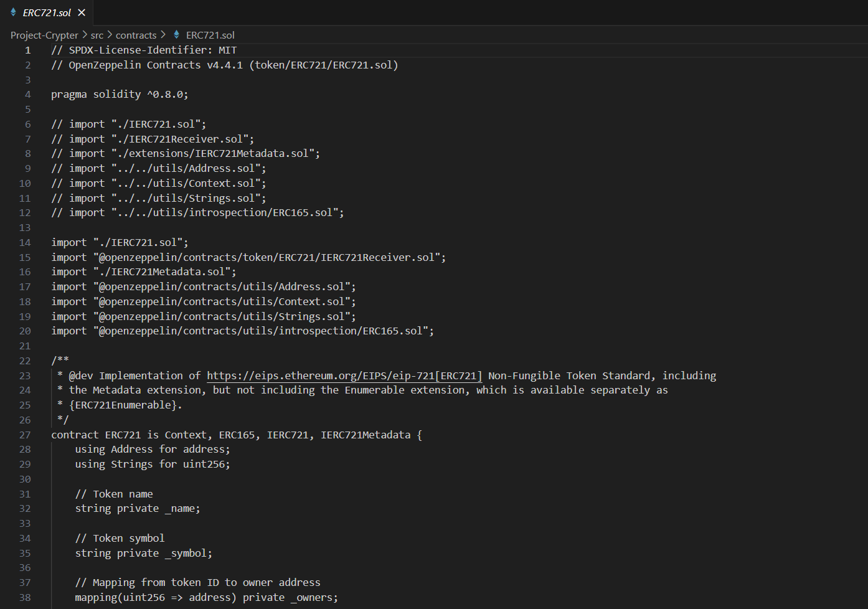

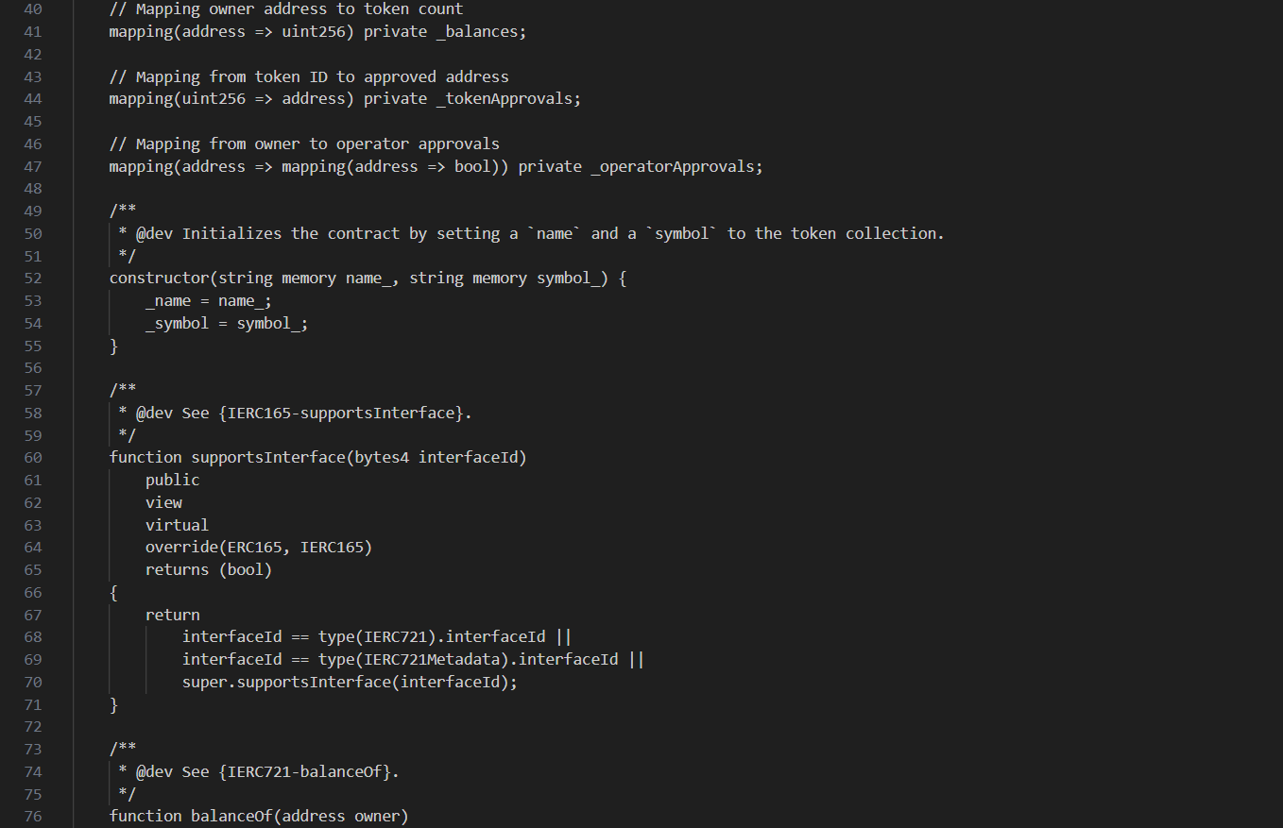

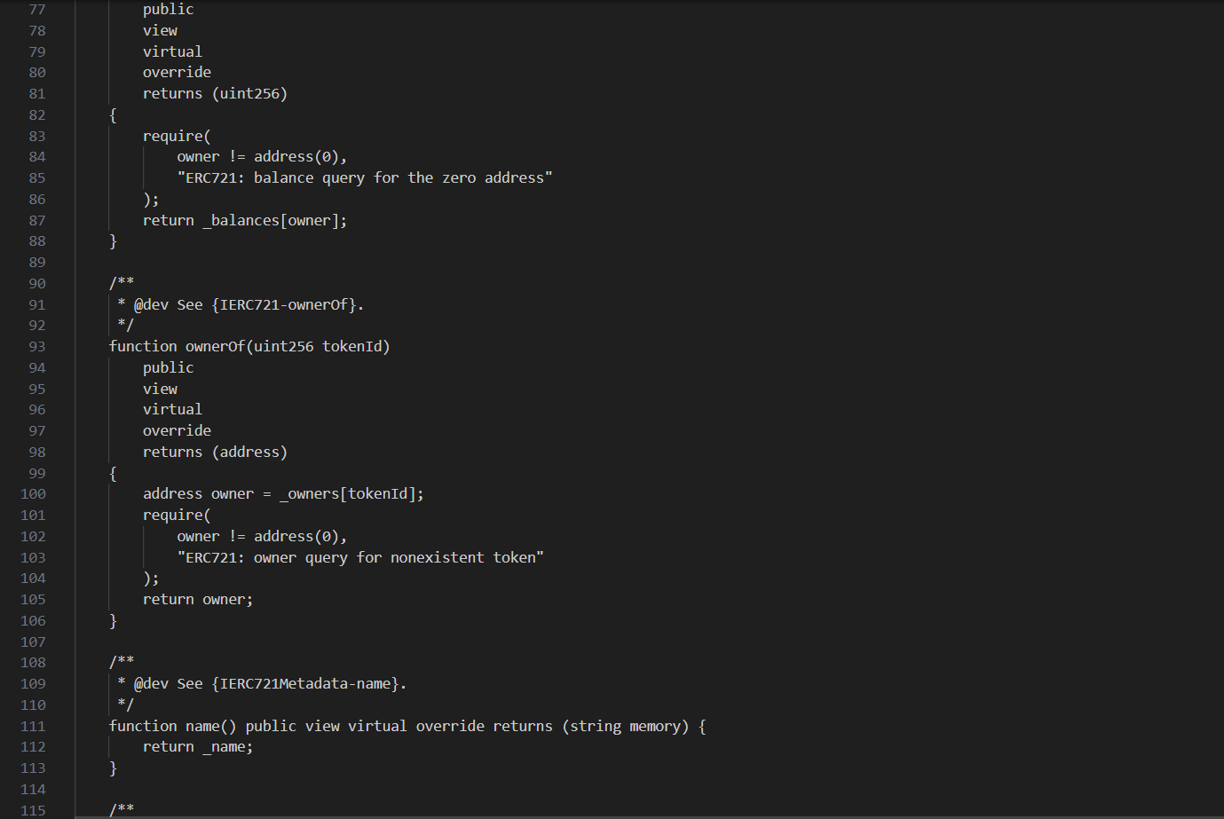

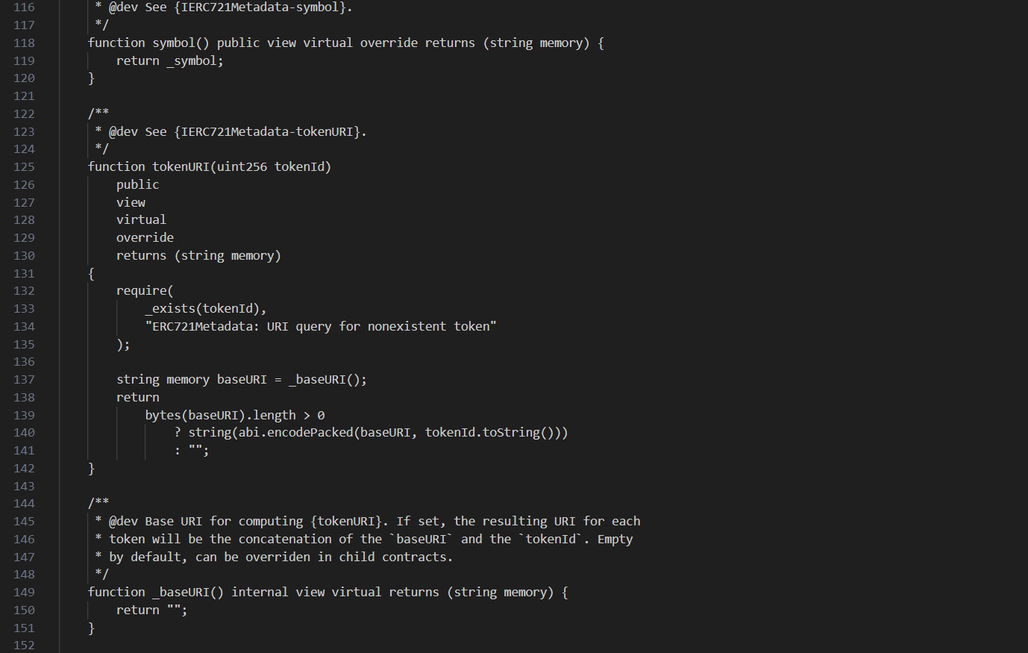

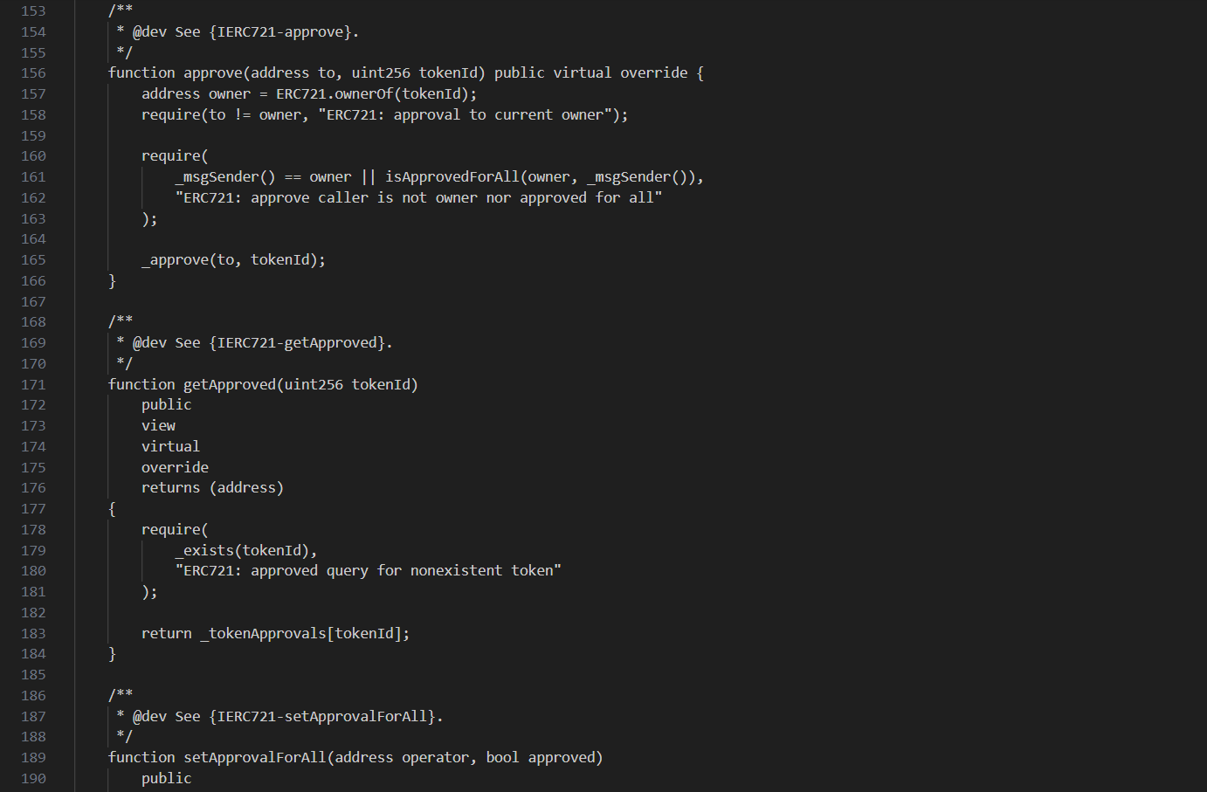

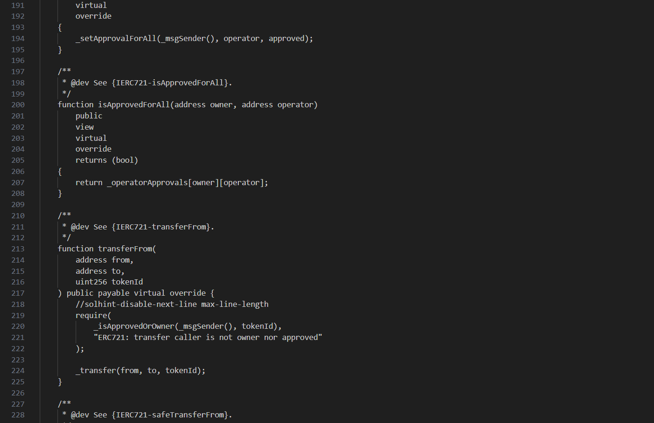

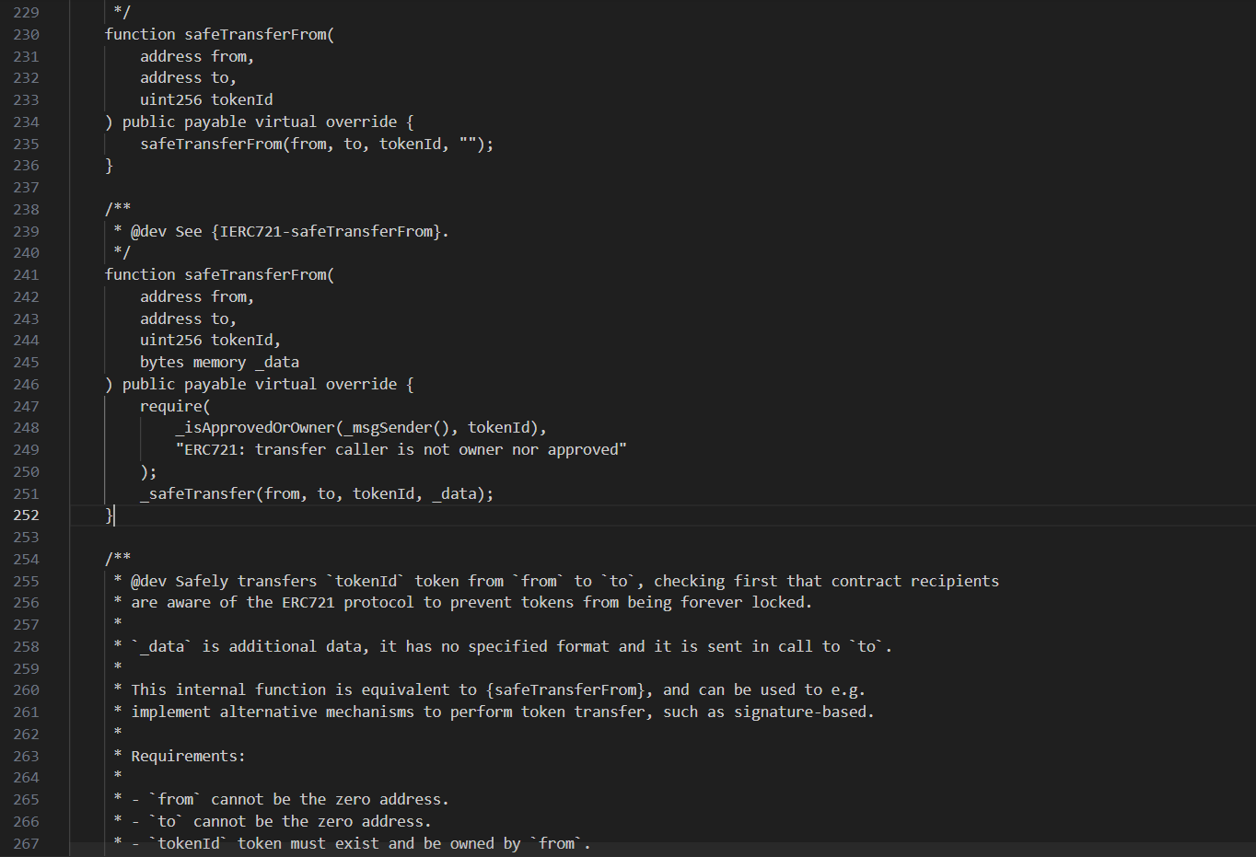

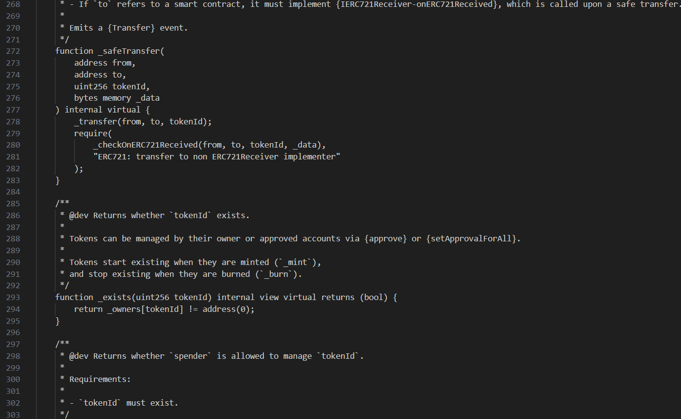

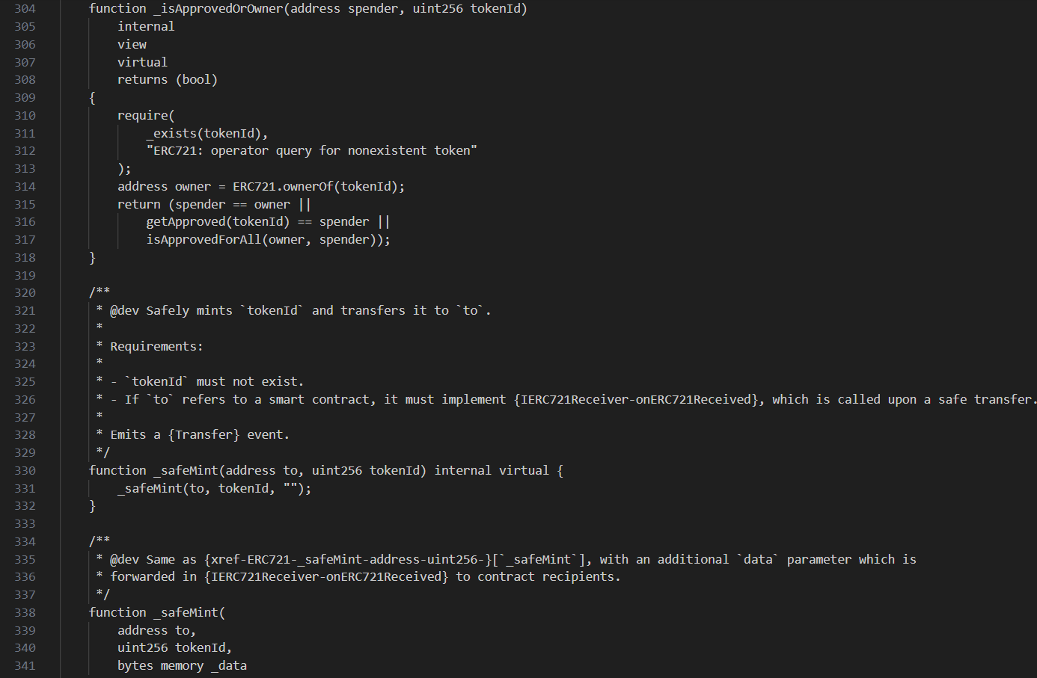

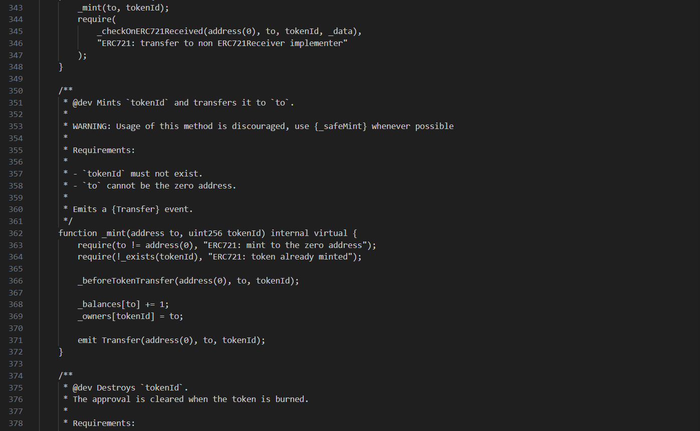

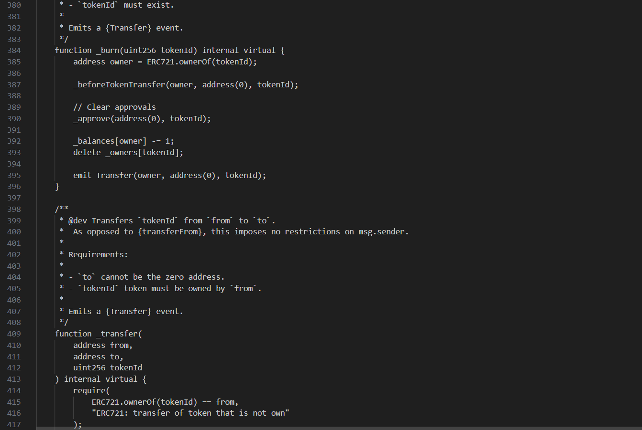

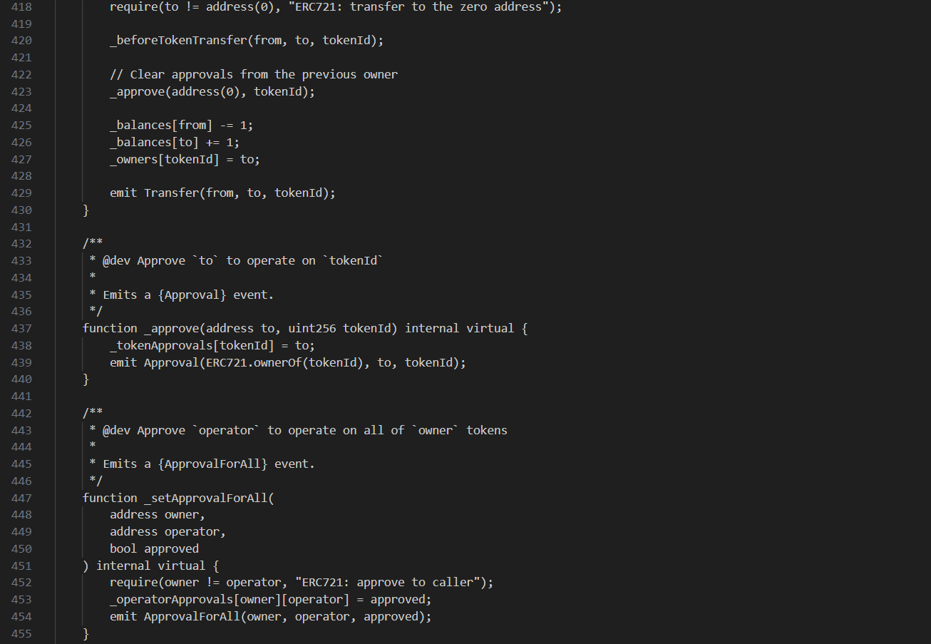

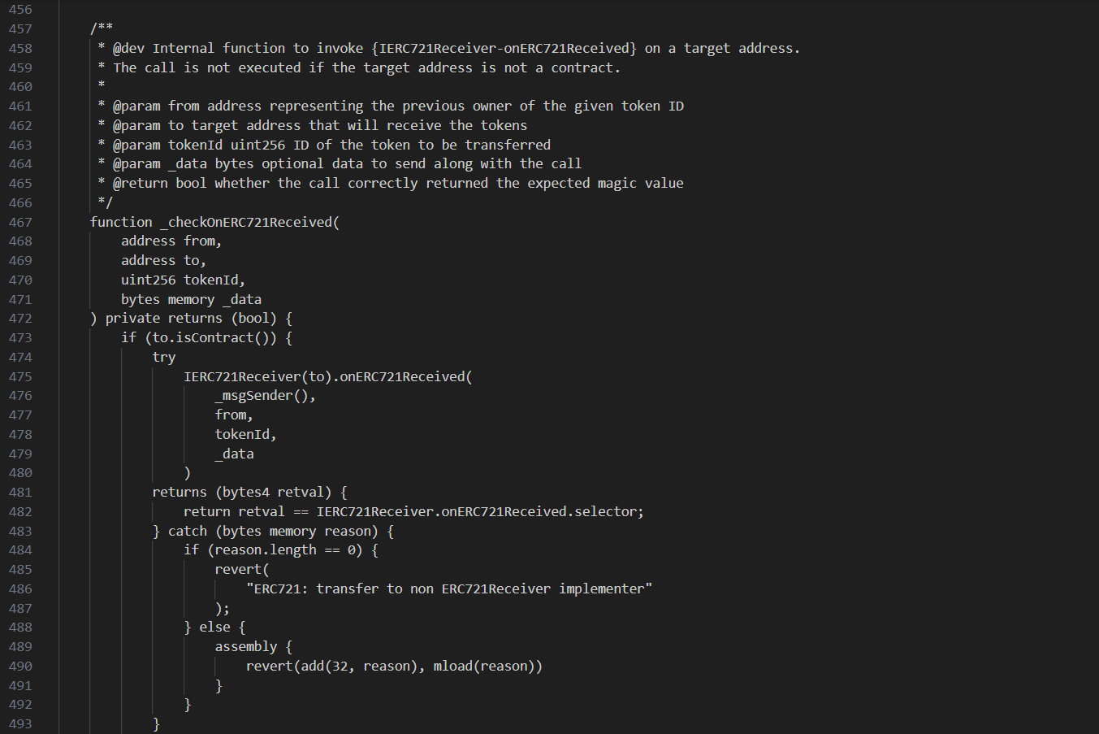

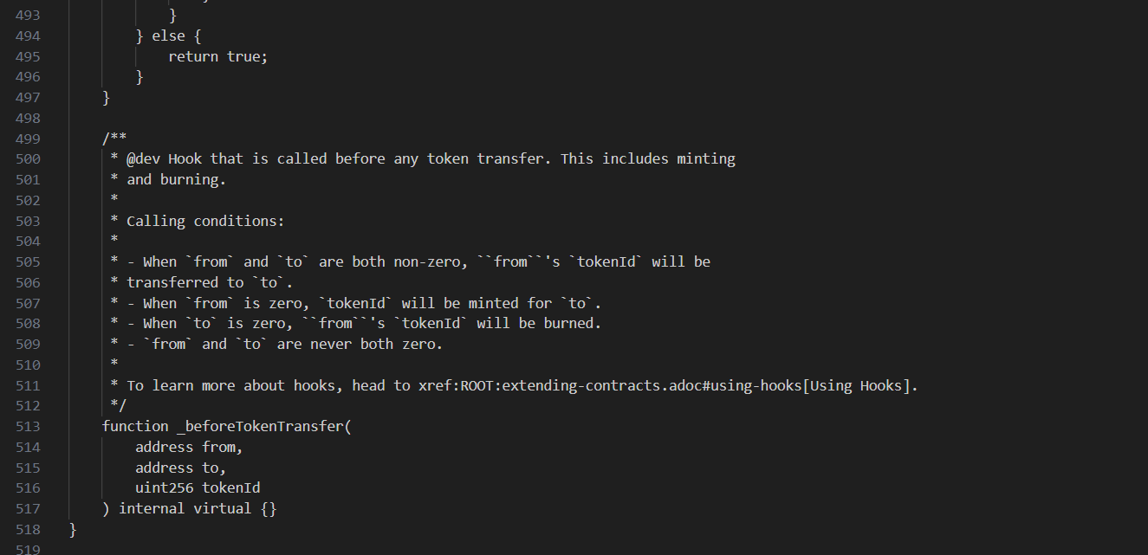

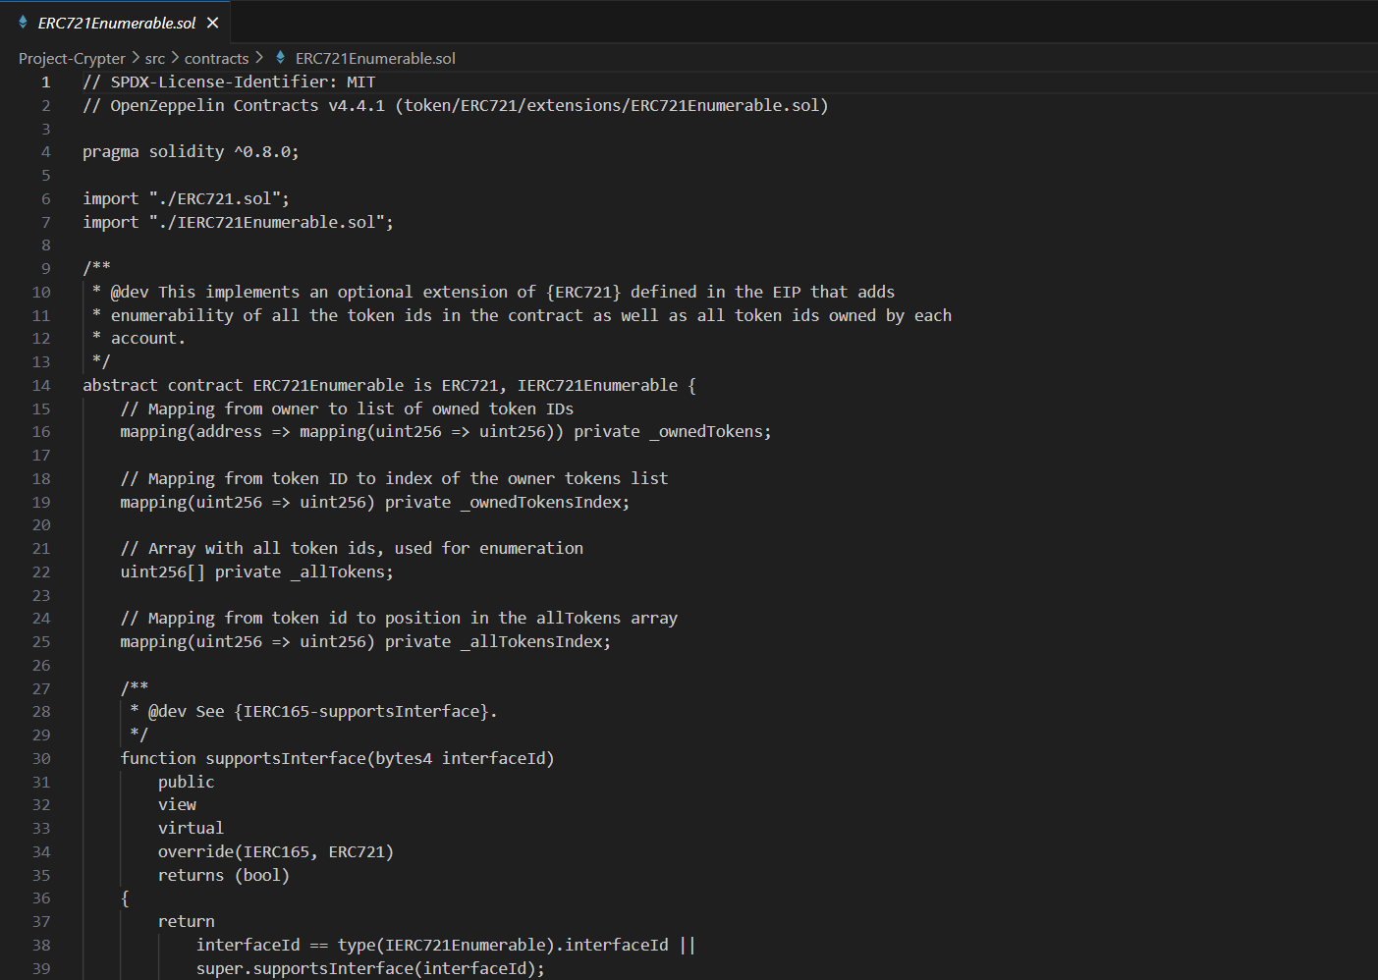

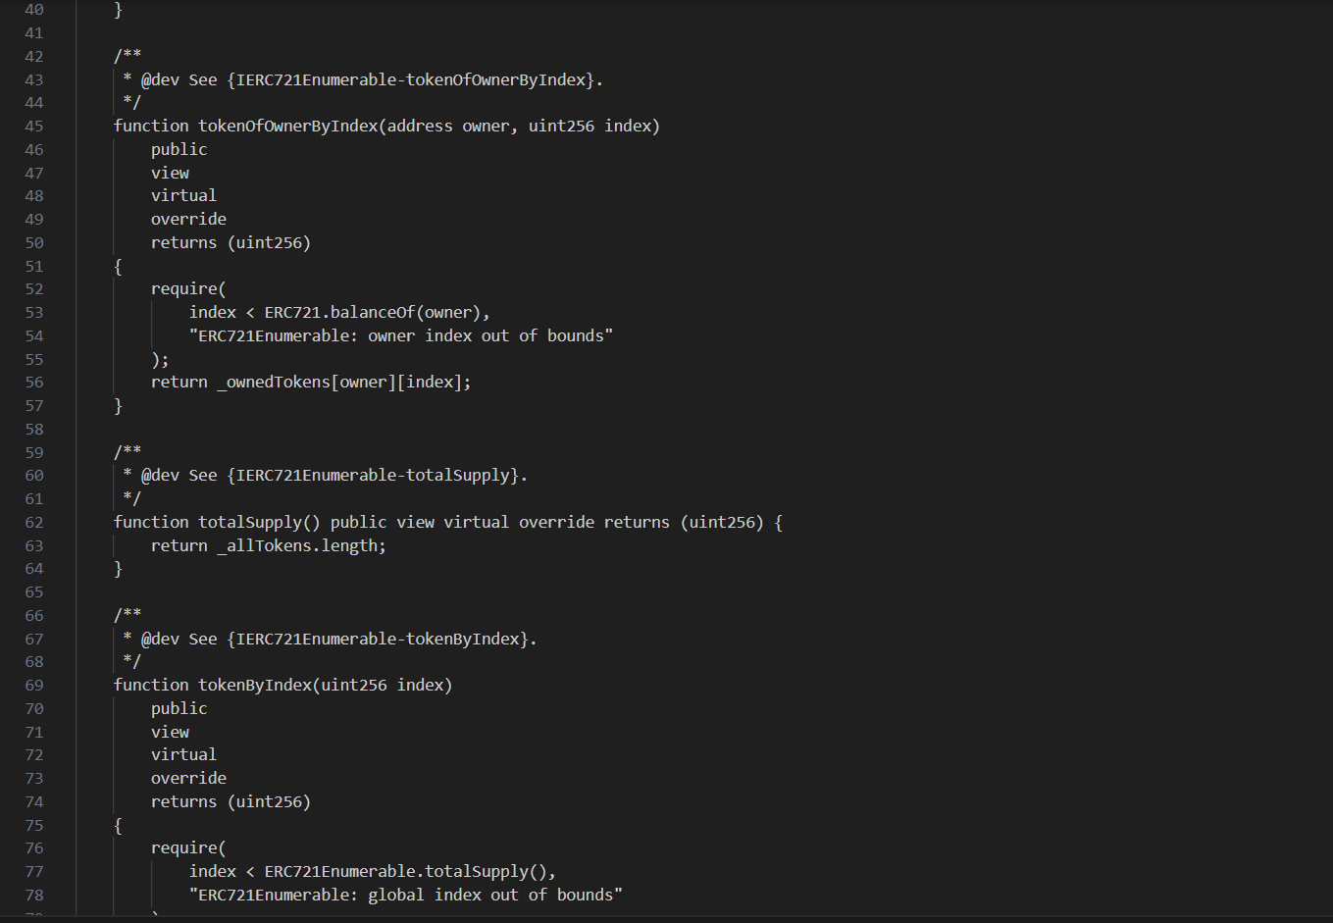

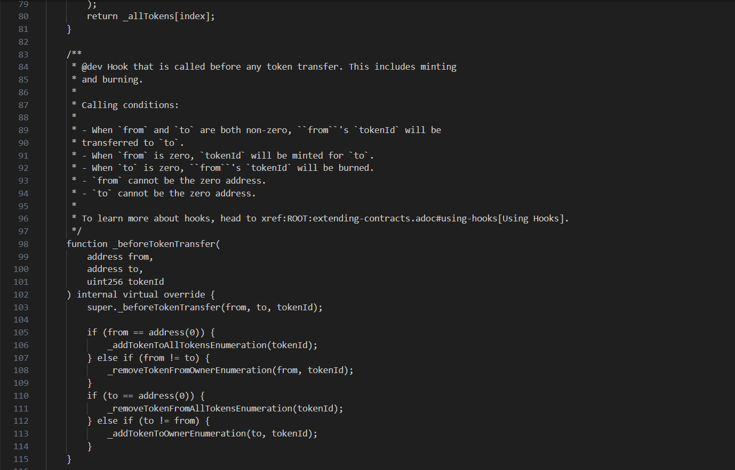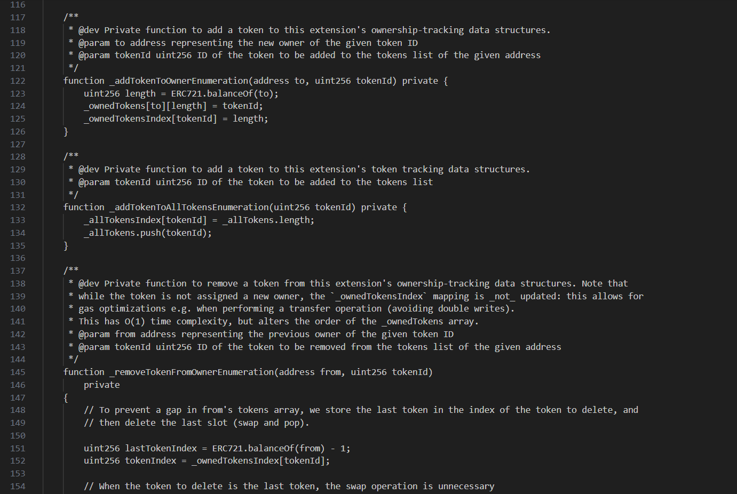

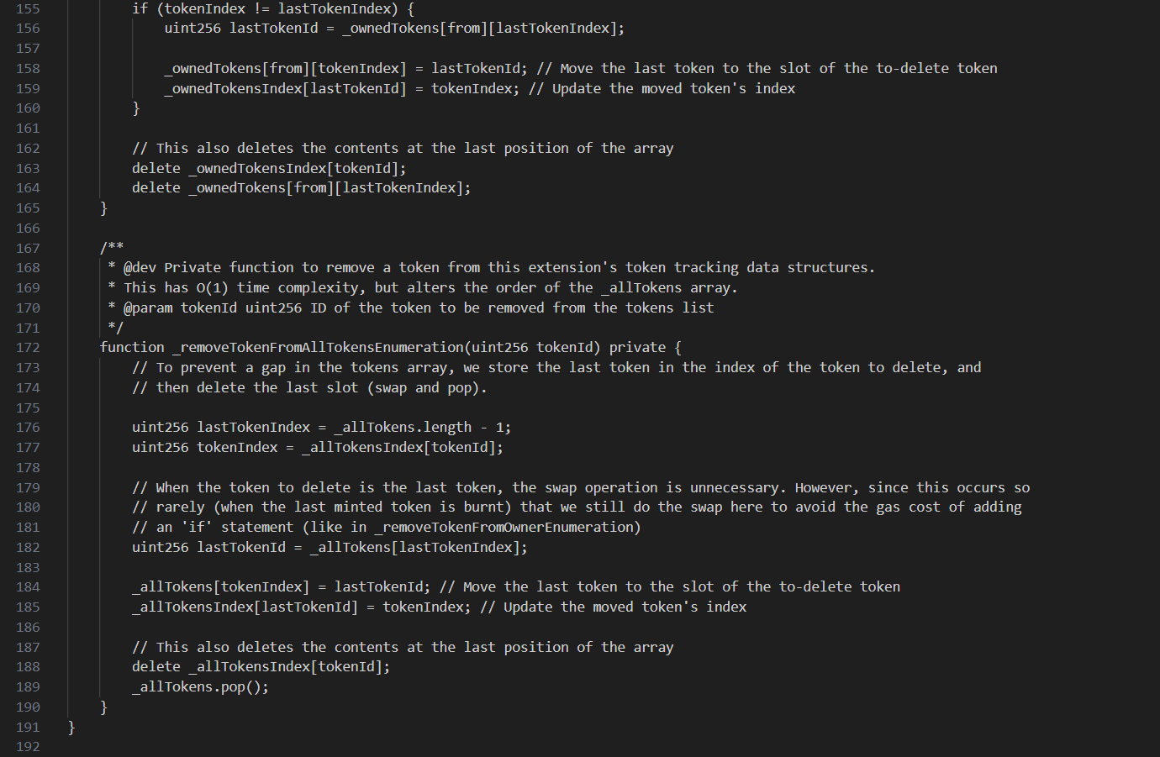

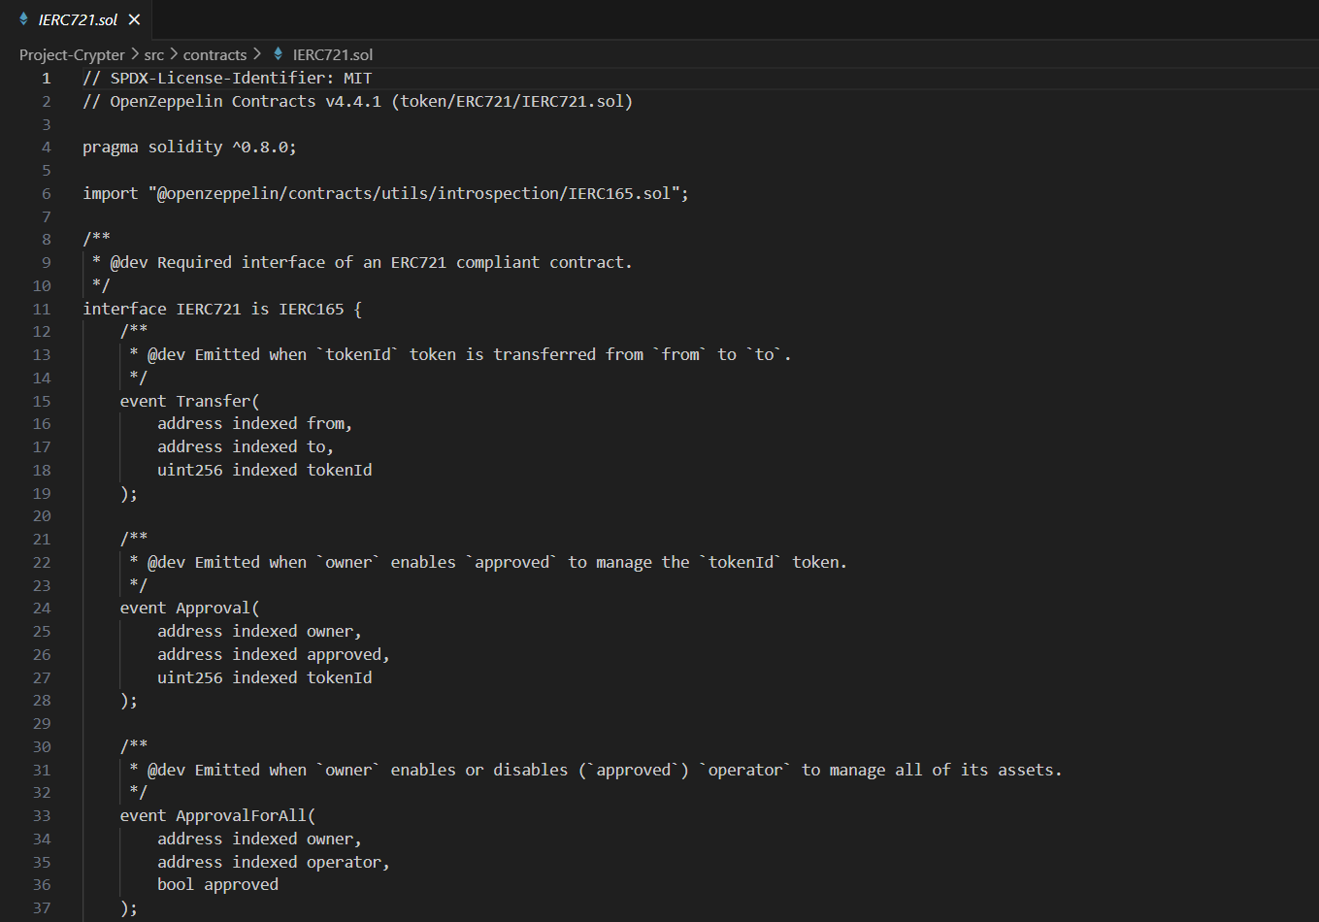

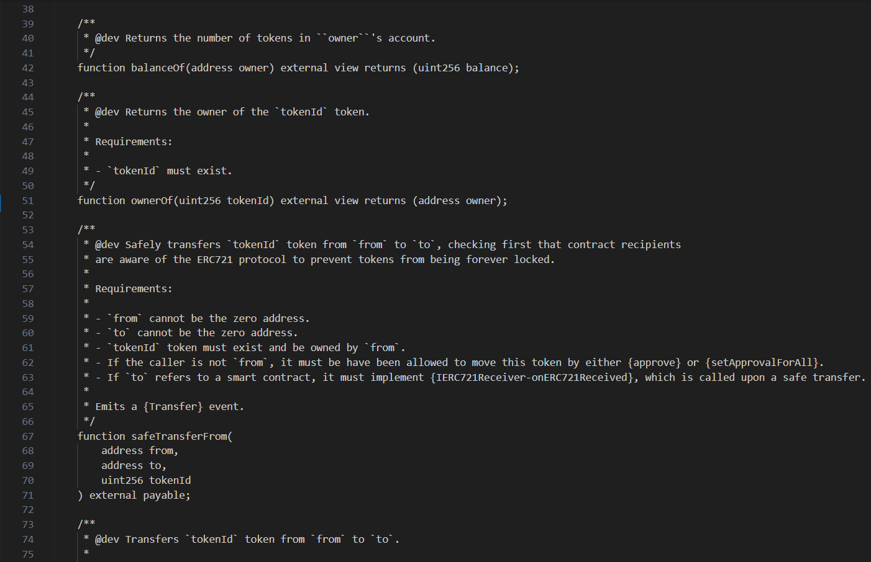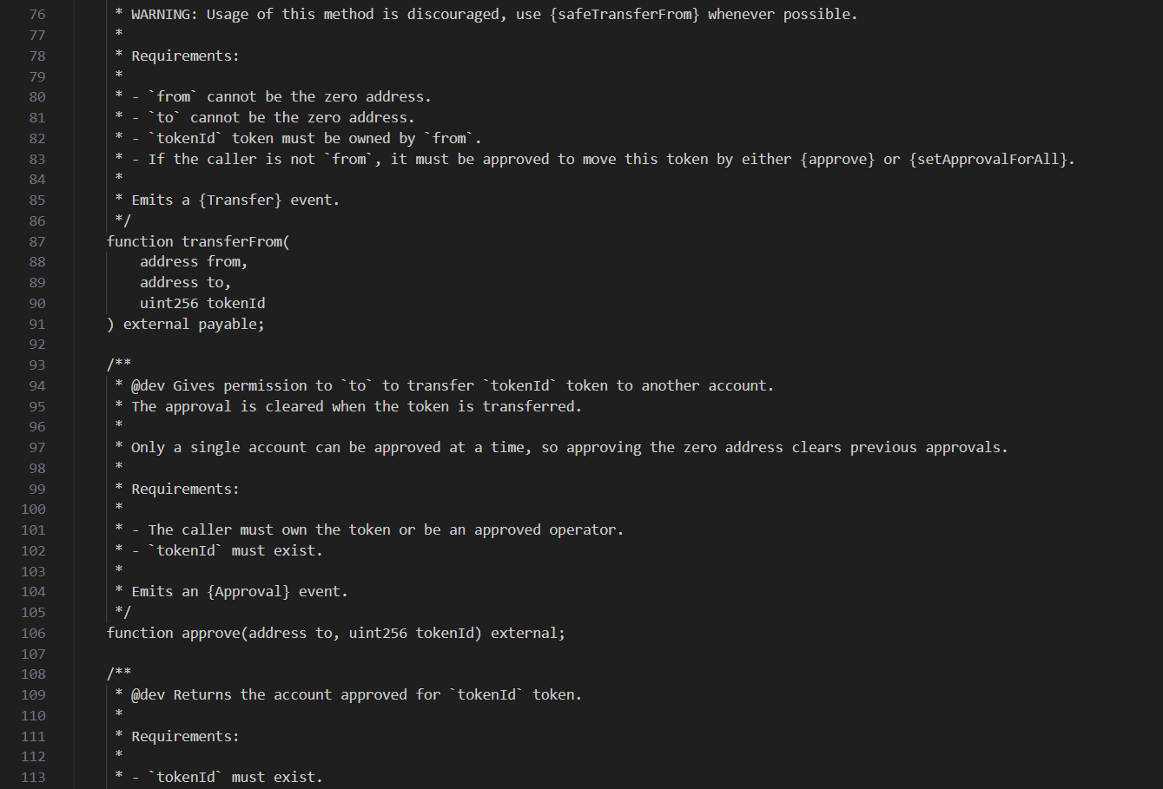

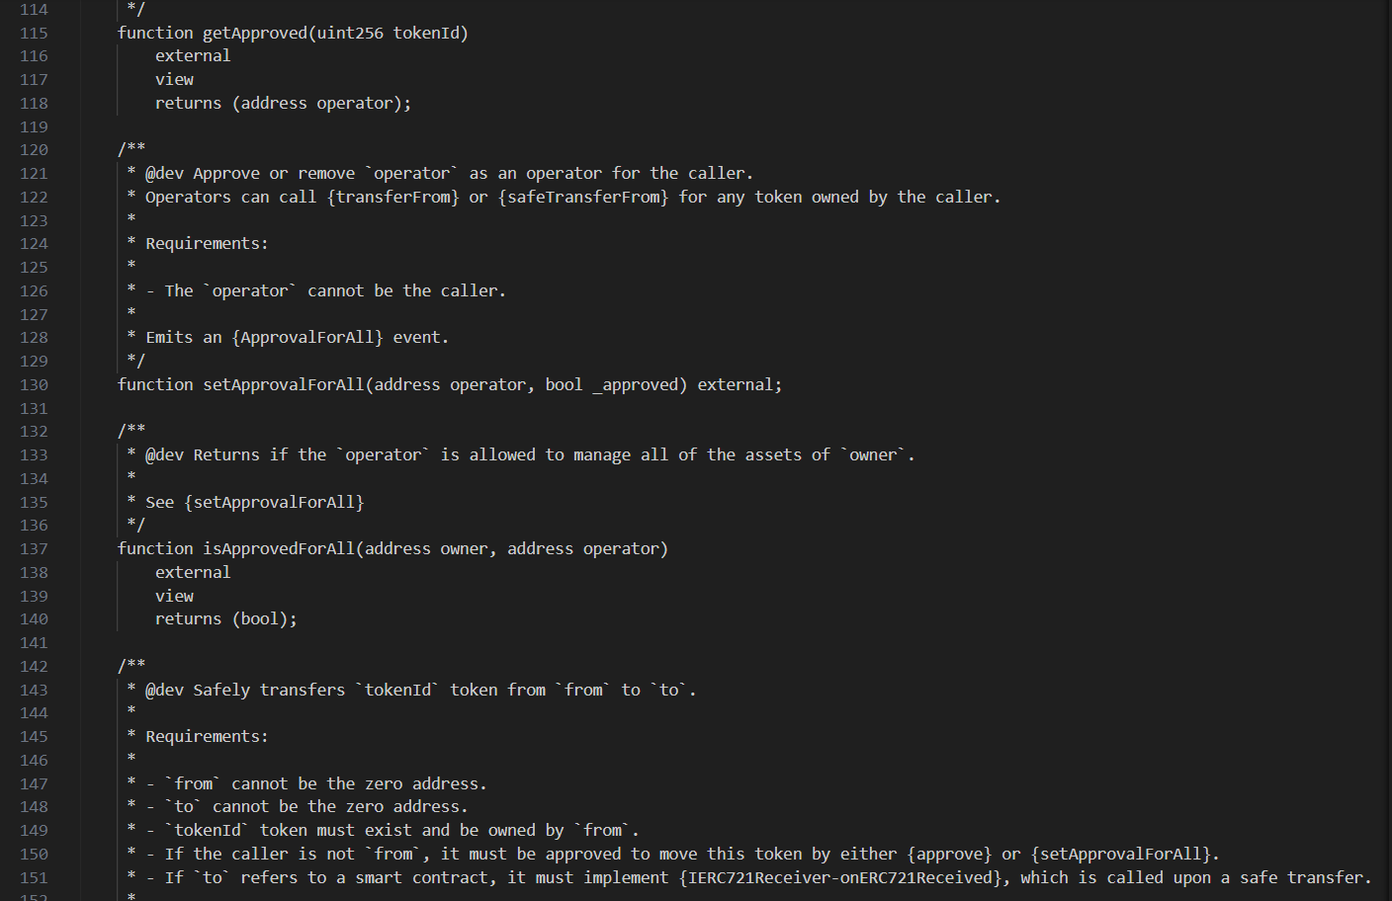

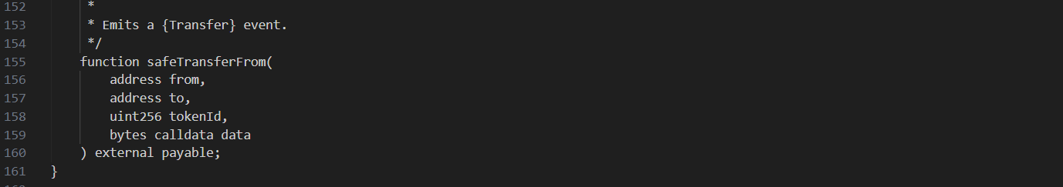

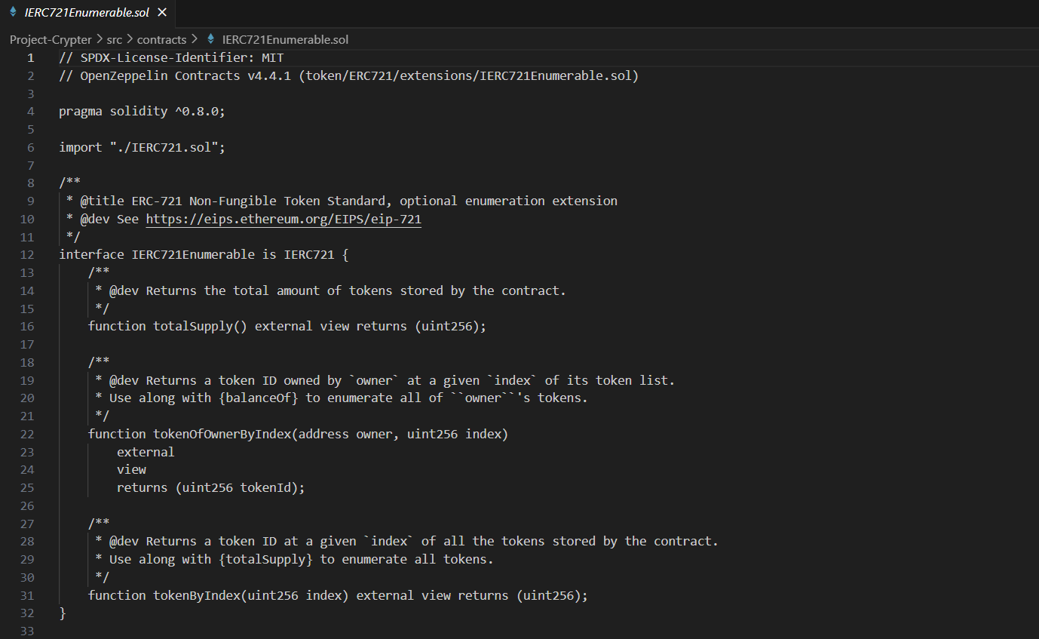

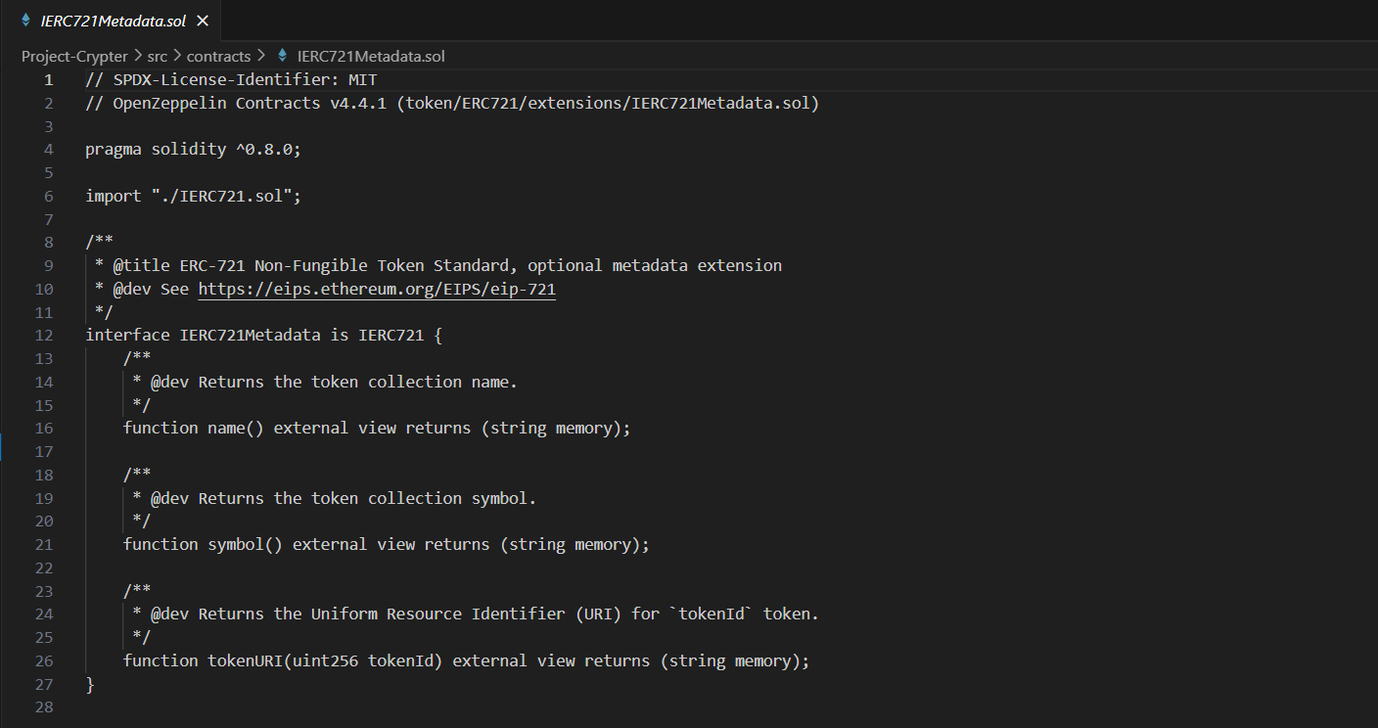

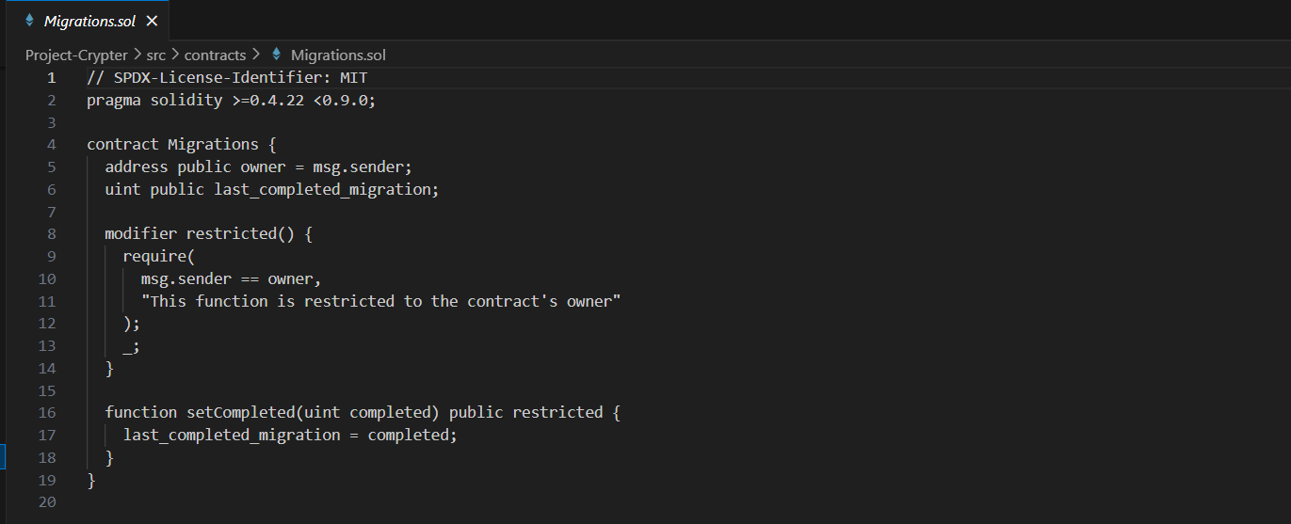

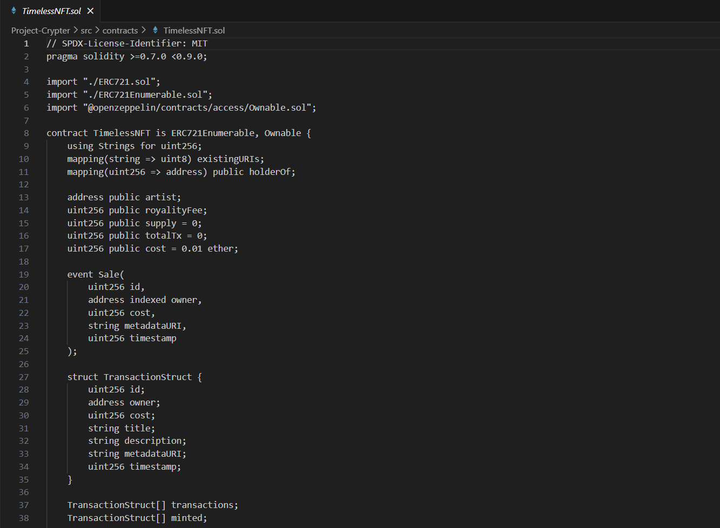

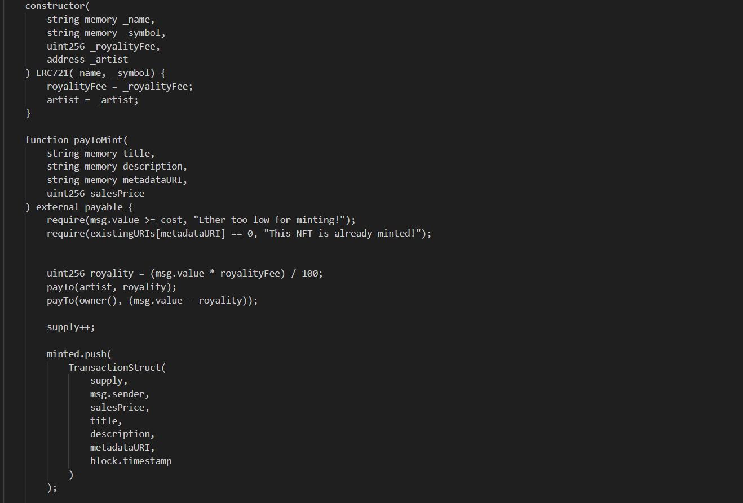

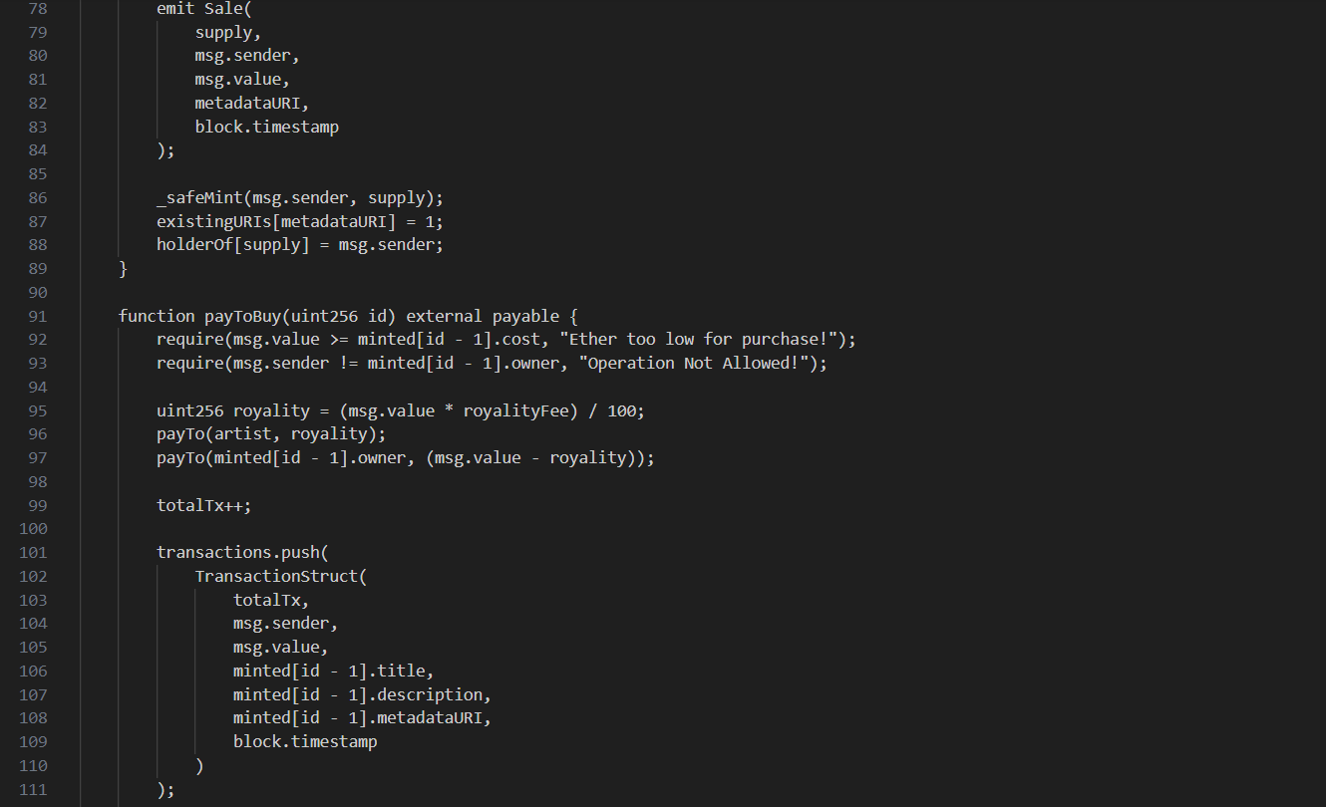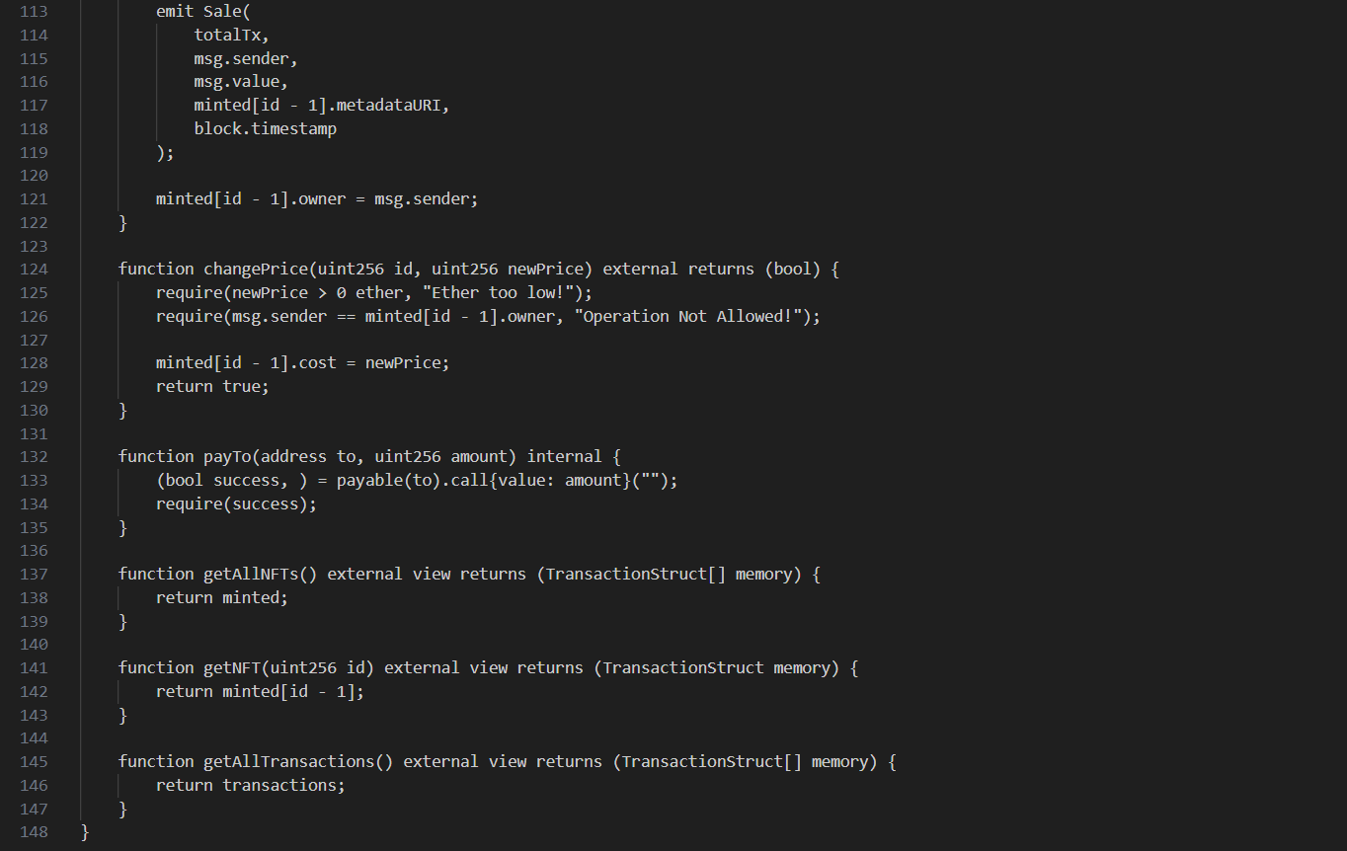

Store:

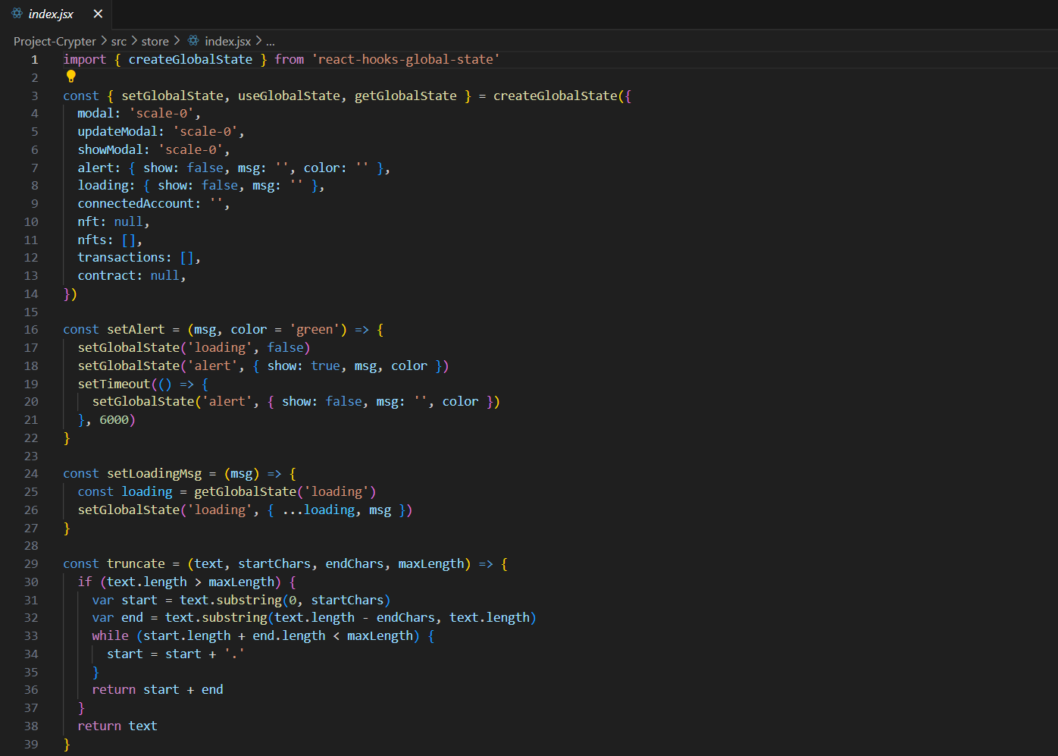

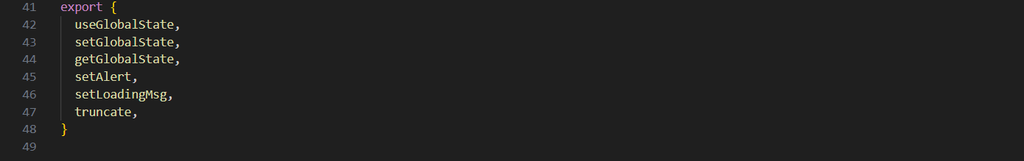

App.jsx:

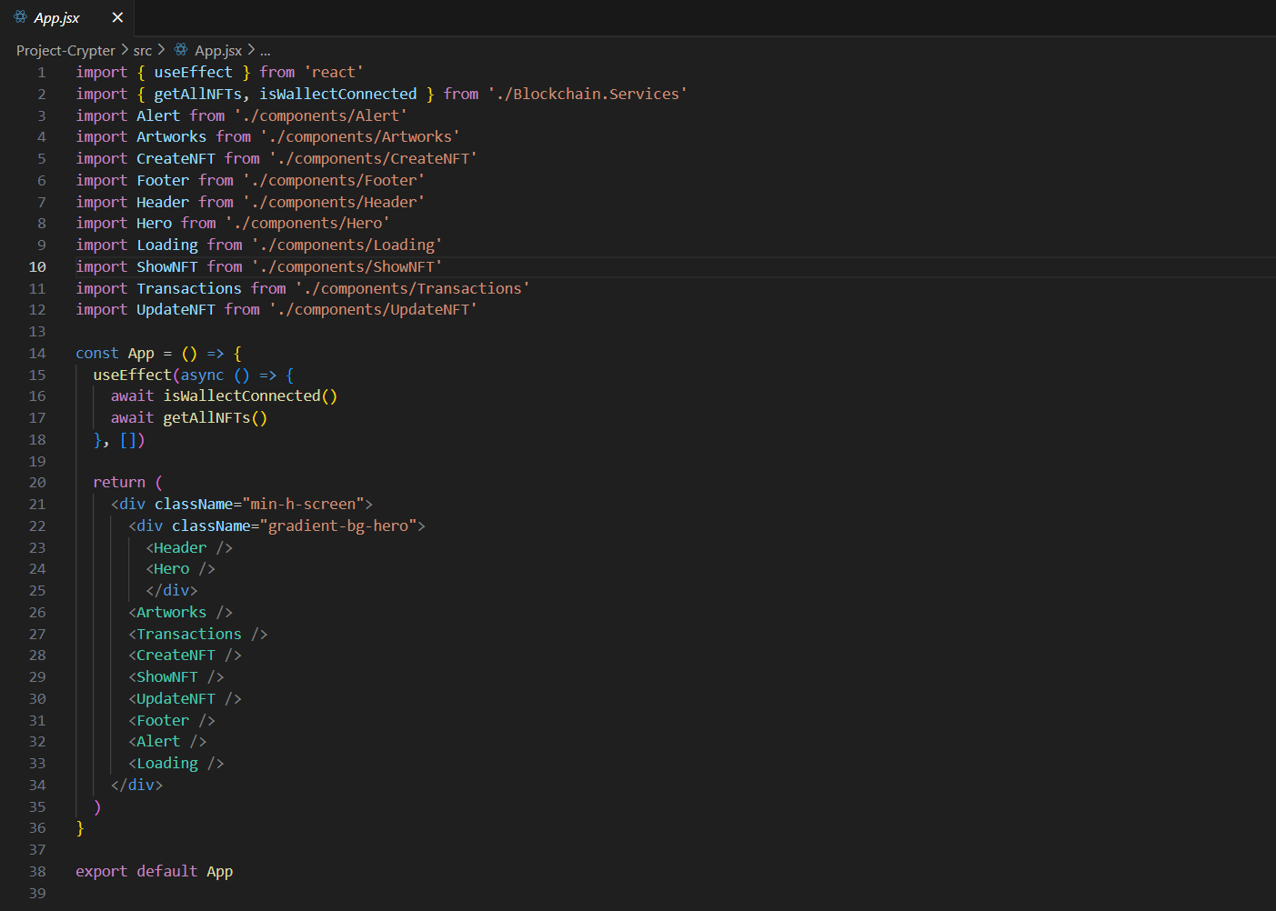

Blockchain.services.jsx

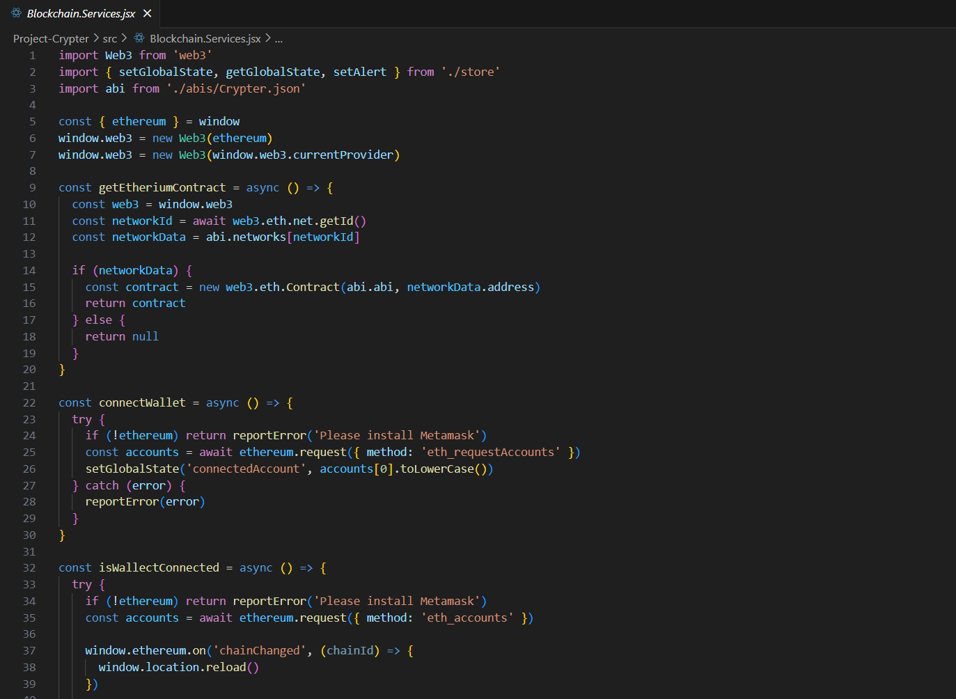

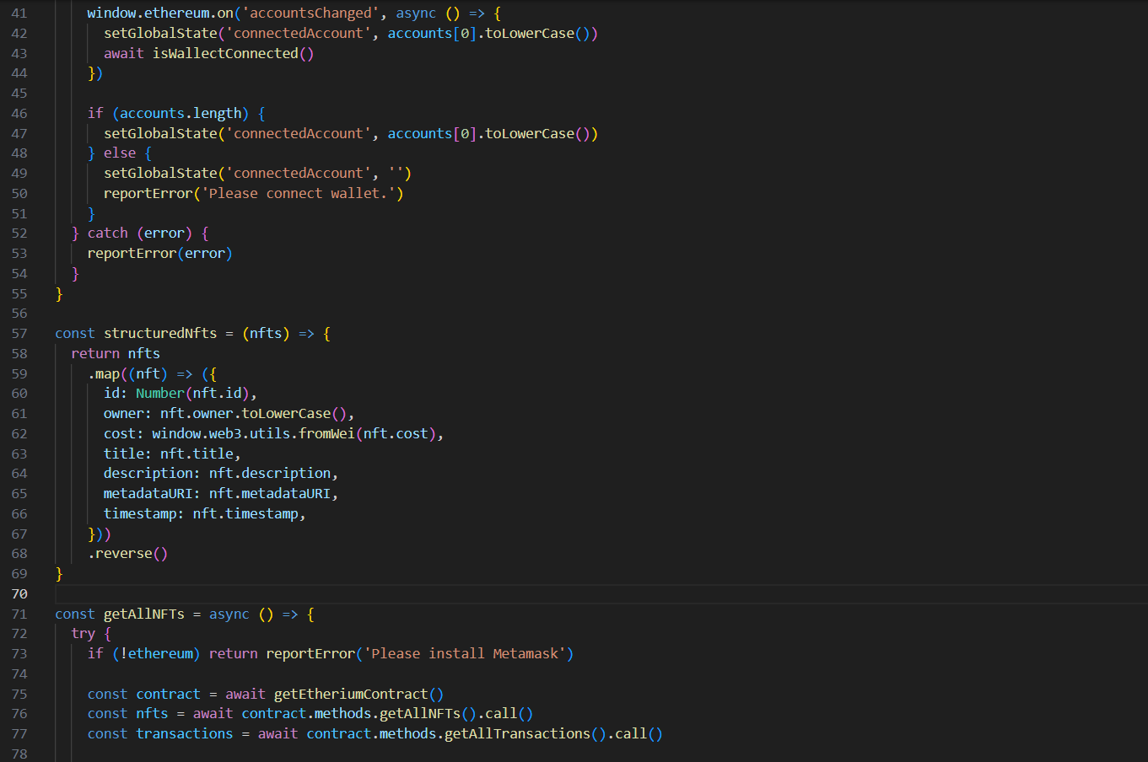

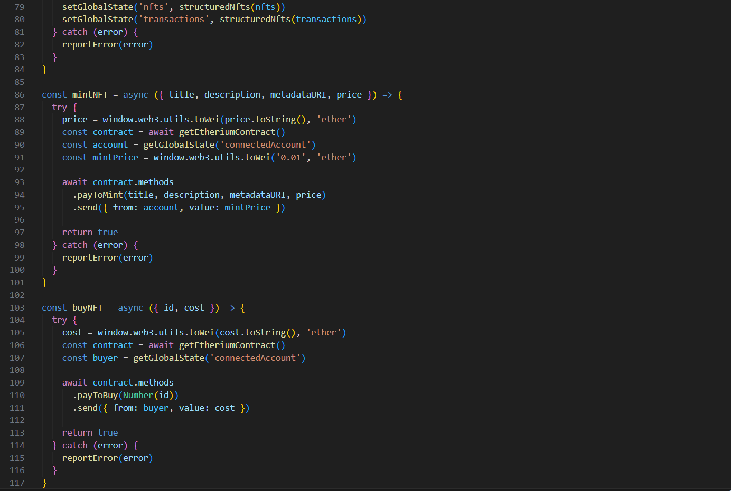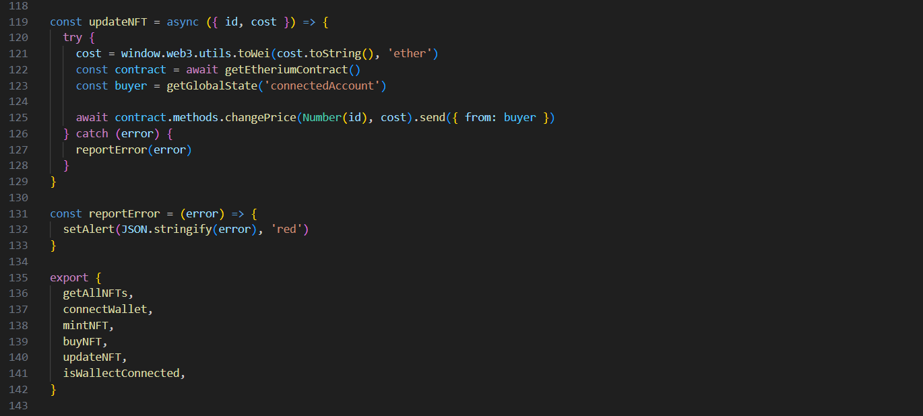

Index.css

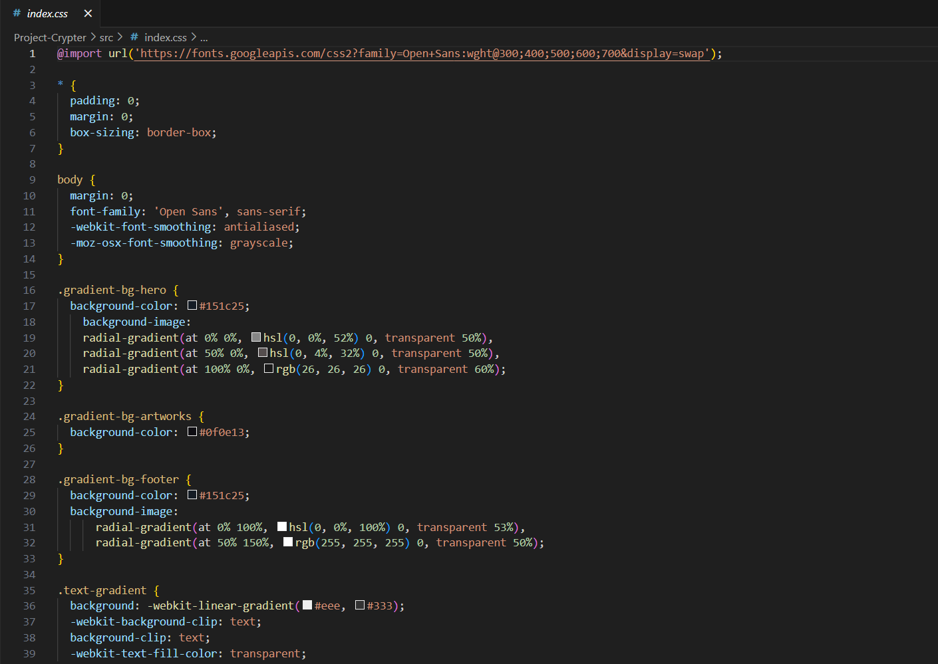

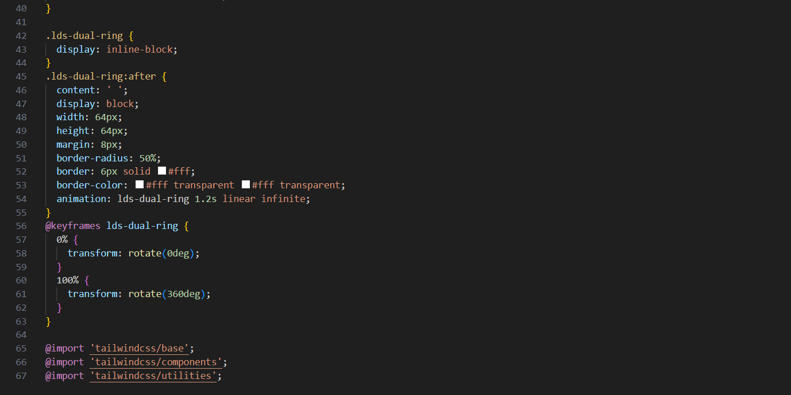

Index.jsx

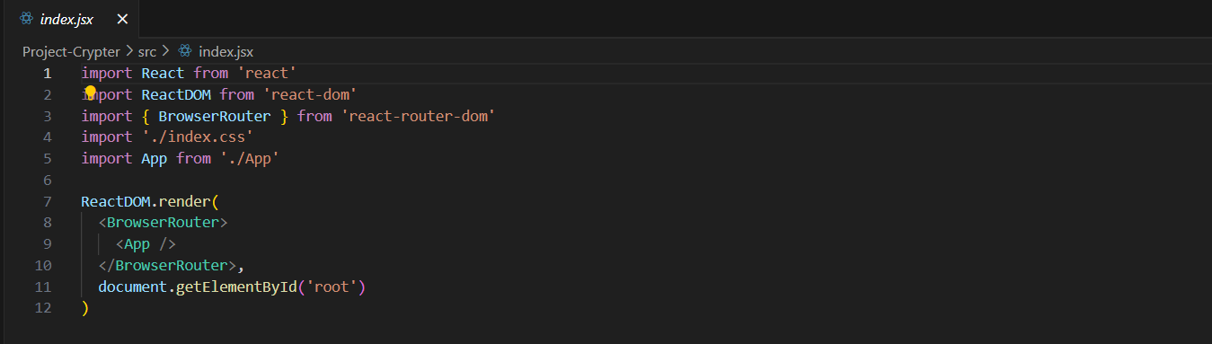

Truffle-config.js

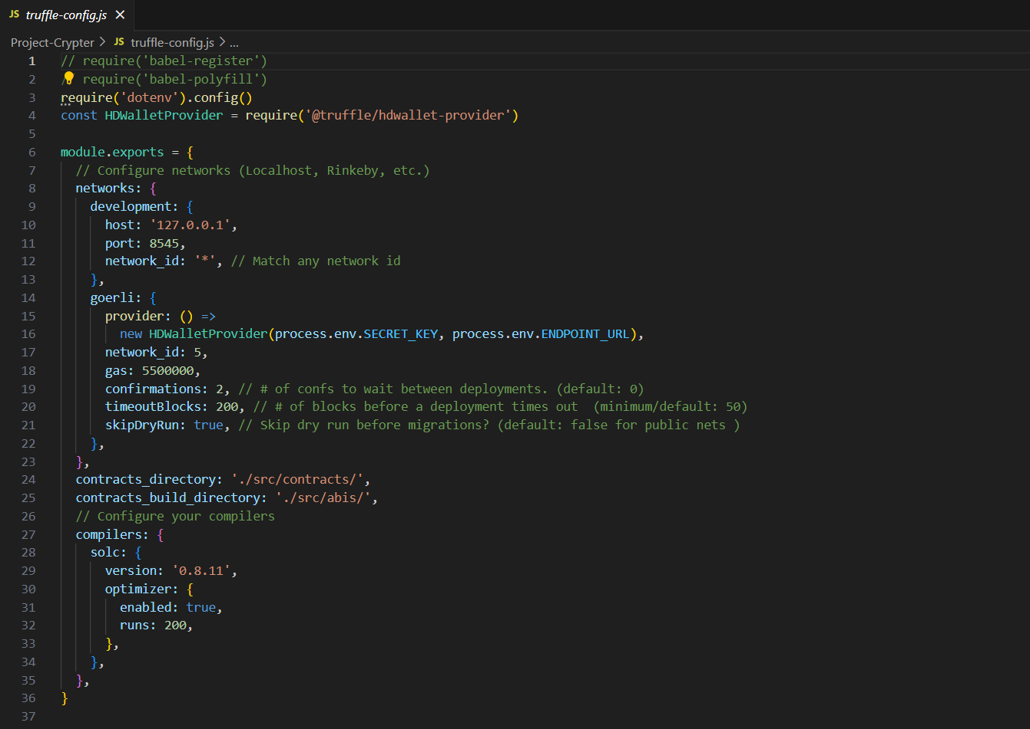

Tailwind.config.js

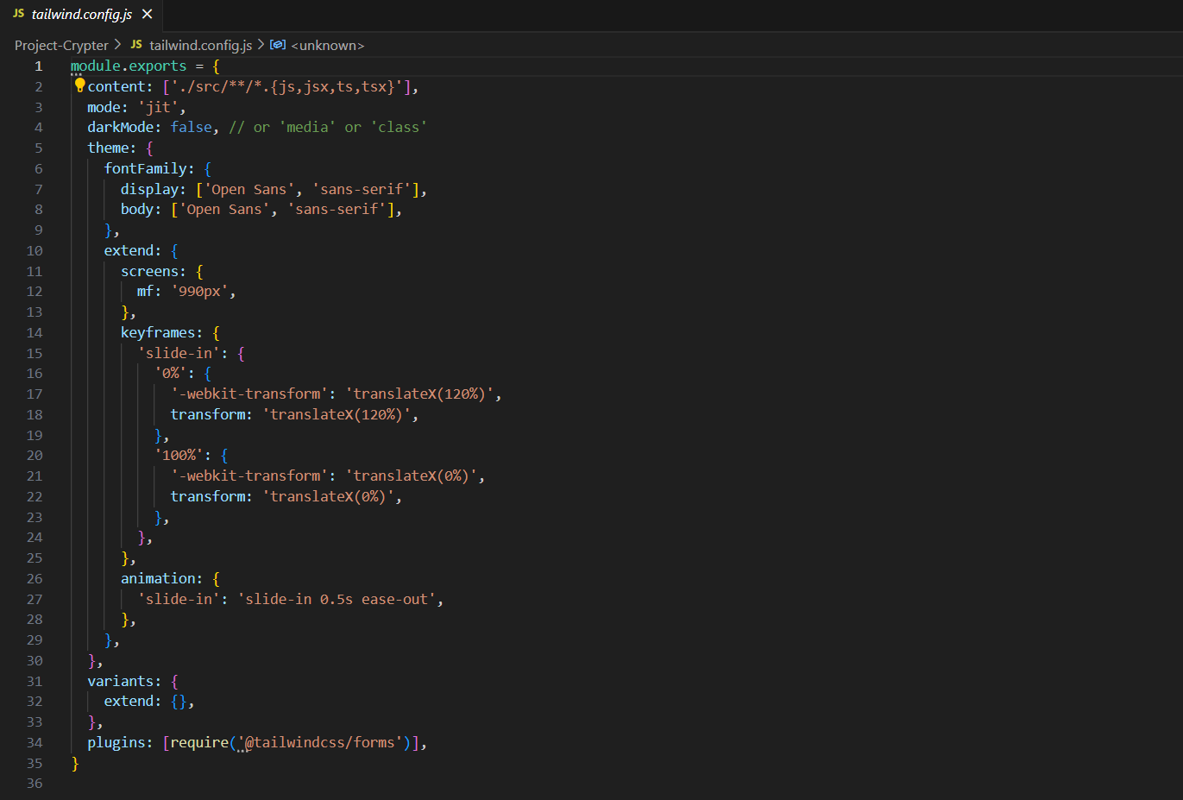

Postcss.config.js

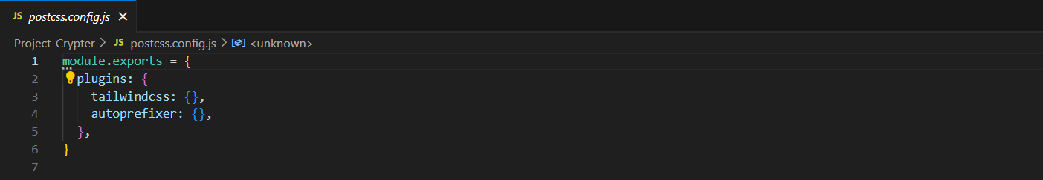

**Project Outcome**

Deliverables:

* + 1. A Fully Functional NFT Marketplace
       - A user-friendly platform allowing users to mint, buy, sell, and trade NFTs across various categories (art, music, gaming, etc.).
    2. Smart Contract
       - Secure and audited smart contracts for creating, transferring, and managing NFTs.
    3. Documentation
       - Comprehensive user guides, FAQs, and developer documentation explaining platform usage, NFT minting, and transaction processes.
    4. Frontend Infrastructure
       - Responsive and intuitive frontend interfaces for web and mobile platforms, enabling seamless user interactions.
    5. Backend Infrastructure
       - Robust backend infrastructure handling user authentication, NFT minting, transaction processing, and database management.

Quality Control:

* + - * 1. Code Review
      * Regular code reviews by experienced developers to identify and fix coding issues, maintain coding standards, and enhance code quality.
    1. Automated Testing
       - Implementation of automated unit tests, integration tests, and end-to-end tests to identify bugs and ensure the functionality of different components.
    2. Security Audits
       - Thorough security audits, including penetration testing and smart contract audits, to identify and address vulnerabilities.
    3. User Testing
       - Alpha and beta testing phases involving internal and limited external users to identify usability issues and gather feedback for improvements.

**Project Evaluation**

Success Criteria:

* + - * 1. User Engagement: Measure user activity, including the number of NFTs minted, transactions conducted, and active users. A successful project will see consistent and growing user engagement over time
        2. Customer Satisfaction: Collect feedback from users to gauge their satisfaction with the platform's usability, features, and customer support.
        3. Security and Reliability: Evaluate the platform's security by monitoring incidents, vulnerabilities, and response times. A successful project ensures a secure and reliable experience for users.
        4. Marketplace Growth: Track the growth of the marketplace in terms of the number of artists, buyers, and transactions. A successful project will witness a steady increase in marketplace activity.

Learnt:

* + - 1. Thorough Planning: Detailed planning and research laid a strong foundation, ensuring the project met its goals.
      2. Collaborative Teamwork: Effective communication and collaboration among team members led to streamlined development processes.
      3. User-Centric Design: Prioritizing user experience and incorporating user feedback resulted in a user-friendly platform.
      4. Continuous Iteration: Regular feedback loops and iterative development allowed for quick adjustments and improvements.

**Conclusion**

The project resulted in the successful creation and launch of a functional and user-friendly NFT marketplace. By focusing on user experience, security, and continuous improvement based on feedback, the project not only met but exceeded user expectations. Through careful planning, iterative development, and active engagement with users, the project achieved its objectives, providing a valuable platform for artists, buyers, and collectors in the NFT space. The lessons learned and recommendations provide valuable insights for future projects, ensuring ongoing success and growth in the dynamic and evolving landscape of digital marketplaces.

**References**

[**https://react.dev/learn**](https://react.dev/learn)

[**https://v2.tailwindcss.com/docs**](https://v2.tailwindcss.com/docs)

[**https://youtu.be/8FRm_efm99o?si=QHTZBs92Y4kzkT0r**](https://youtu.be/8FRm_efm99o?si=QHTZBs92Y4kzkT0r)

[**https://youtu.be/2bjVWclBD_s?si=8TeDOV6l-29NGrRI**](https://youtu.be/2bjVWclBD_s?si=8TeDOV6l-29NGrRI)

[**https://www.geeksforgeeks.org/how-to-install-and-use-metamask-on-google-chrome/**](https://www.geeksforgeeks.org/how-to-install-and-use-metamask-on-google-chrome/)